**EXERCISE GUIDE**

**Salesforce Hyperautomation**

**with MuleSoft**

**SFADX-350SP23v1-EN-SG**

**SFADX-350SP23v1-EN-SG**

**Salesforce Hyperautomation**

**with MuleSoft  
EXERCISE GUIDE**

**Table of Contents**

**Exercise 1-0: Setup your computer and environments.** **4**

**Exercise 1-1: Use API Designer to define an API with RAML** **6**

**Exercise 1-2: Use the mocking service to test an API** **11**

**Exercise 1-3: Add request and response details** **13**

**Exercise 1-4: Add an API to Anypoint Exchange** **21**

**Exercise 1-5: Share an API** **24**

**Exercise 2-1: Create a Mule application with Anypoint Studio** **26**

**Exercise 2-2: Connect to data** **30**

**Exercise 2-3: Transform data** **32**

**Exercise 2-4: Create a RESTful interface for a Mule application** **37**

**Exercise 2-5: Deploy an application to CloudHub** **44**

**Exercise 2-6: Create and deploy an API proxy** **46**

**Exercise 2-7: Update the API proxy to use HTTPS** **48**

**Exercise 2-8: Secure API access with policies** **51**

**Exercise 3-1: Create and evaluate an RPA process** **54**

**Exercise 3-2: Design an RPA process** **57**

**Exercise 3-3: Build an RPA process** **60**

**Exercise 3-4: Install and set up an RPA Bot** **70**

**Exercise 3-5: Test and publish an RPA process** **72**

**Exercise 4-1: Create and configure platform access** **74**

**Exercise 4-2: Create an External Service** **77**

**Exercise 4-3: Configure MuleSoft Composer** **79**

**Exercise 5-1: Create the EV Case Parts flow** **80**

**Exercise 5-2: Modify the EV Vehicle Promotions flow** **85**

**Exercise 5-3: Modify the EV Create Case flow** **88**

**Exercise 5-4: Create the Promotional Rebates MuleSoft Composer flow** **90**

**Exercise 5-5: Create the Service Case Closed MuleSoft Composer flow** **94**

**Exercise 5-6: Create the EV Scheduled Service Orchestration** **99**

**Exercise 6-1: Create an Einstein chatbot** **105**

**Exercise 6-2: Create an Experience Cloud support site** **111**

# 

# Exercise 1-0: Set up your computer and environments.

**Goal:**

Install the required software on your computer and create new accounts for the various services used throughout the course.

**Tasks:**

1. Signup for an Anypoint Platform Account
2. Install Anypoint Studio
3. Install Advanced REST Client
4. Log into Salesforce
5. Configure Google Sheets
6. Configure Slack

**Time:**

20 minutes

**Instructions:**

1. Signup for an Anypoint Platform Account.
   1. Open Google Chrome or another internet browser and navigate to https://anypoint.mulesoft.com/login/signup.

**NOTE:** *Google Chrome is recommended for all exercises in this course.*

* 1. Fill out the form and check your email for the confirmation.

1. Install Anypoint Studio.
   1. Download and install the latest version of Anypoint Studio from https://www.mulesoft.com/lp/dl/studio.
   2. Start the application.

**NOTE:** *Windows users may get a popup asking to allow Windows Defender Firewall access for OpenJDK; access should be allowed.*

* 1. In the Workspace Launcher dialog box, select the workspace location and click **OK**.
  2. If you receive an Updates Available notification in the lower-right corner of the application, click it and install the available updates.

1. Install Advanced REST Client.
   1. Download and install Advanced REST Client from https://install.advancedrestclient.com.
2. Log in to and set up Salesforce.
   1. Open your browser to http://login.salesforce.com and login.

**NOTE:** *Your instructor will provide you with your credentials.*

* 1. In the Search fields, enter **Tristin Chris** and select the resulting contact record.
  2. Update the contact with your email address.
  3. Click  > **Settings** and enter your email address.
  4. Click **Save**.
  5. Check your inbox for the email, “Finish changing your Salesforce account’s email address”.
  6. Click the link to finish changing your email.
  7. Click **Continue** on the confirmation page.

1. Configure Google Sheets.

**NOTE:** *Sign up for a Google account* [*here*](https://accounts.google.com/signup/v2/webcreateaccount?flowName=GlifWebSignIn&flowEntry=SignUp) *if you do not have one or would like to create a new one.*

* 1. Create a new Sheet with the name, **EVs R Us Service Followup**.
  2. Add the following columns:
     + Case
     + Name
     + Phone
     + Email
     + Appointment Date
     + Completion Date
     + Service Performed

1. Configure Slack

**NOTE:** *Sign up for a Slack workspace* [*here*](https://slack.com/get-started#/createnew) *if you do not have one or would like to create a new one.*

* 1. Create a new **#accounting** channel

# 

# Exercise 1-1: Use API Designer to define an API with RAML

**Scenario:**

Start designing an API with RAML, focusing on the resources and methods.

**Goal:**

Create an API specification with multiple GET and POST resources.

**Tasks:**

1. Create a new API spec.
2. Define resources and nested resources.
3. Define GET and POST methods.

**Time:**

30 minutes

**Instructions:**

1. Navigate to the Anypoint Platform login page.
   1. Open Google Chrome or another internet browser and navigate to https://anypoint.mulesoft.com.

**NOTE:** *Google Chrome is recommended for all exercises in this Exercise Guide.*

1. Log in to Anypoint Platform.
   1. Enter your Username and Password.
   2. Click **Sign In**.
2. Expand the main menu in the upper left and click **Design Center**.
3. Click the **Create +** button and select **New API Specification**.

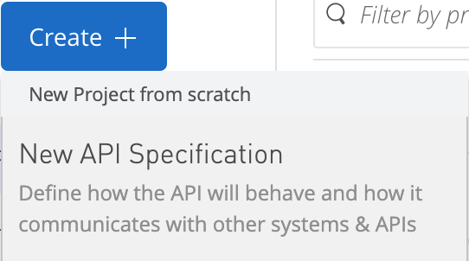

1. In the New API Specification dialog box, set the project name to **Awesome Car Company API**.
2. Ensure **I’m comfortable designing it on my own** is selected, and click **Create API**.
3. After API Designer opens, review the three sections: the file browser, the editor, and the API console.

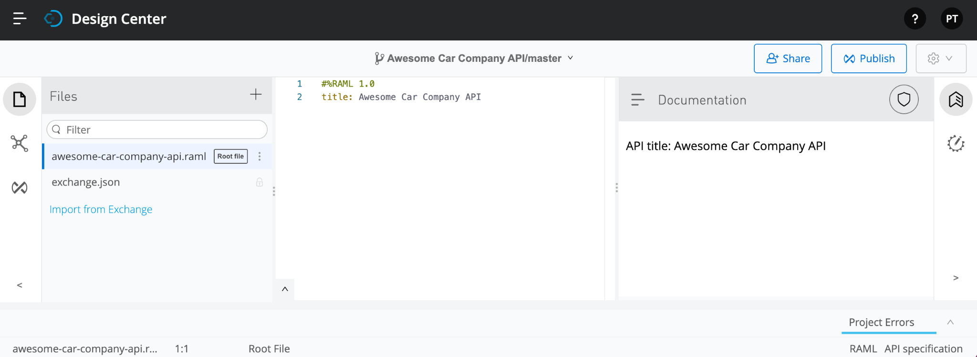

1. Add RAML resources
   1. In the editor, place the cursor on a new line of code at the end of the file.
   2. Add a resource called **vehicles**.
   3. Add two more lines of code and backspace as far as you can.
   4. Add a resource called **promotions**.

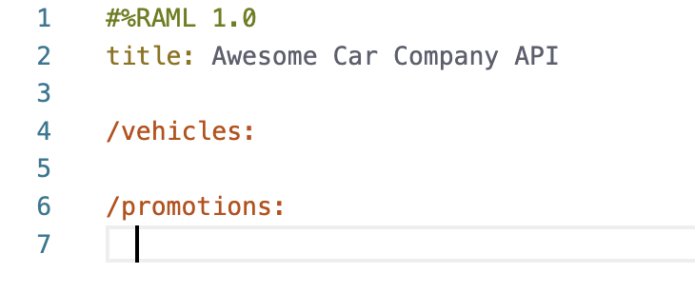

1. Add RAML methods
   1. In the editor, go to a new line of code and backspace so you are indented the same amount as the promotions resource; look at the contents of the API Designer shelf.

**NOTE:** *If you don’t see the API Designer shelf, it is either minimized or there is an error in your code. To check if it is minimized, go to the bottom of the web browser window and look for an arrow. If you see the arrow, click it to display the shelf.*

* 1. Indent by pressing the **Tab** key; the contents in the API Designer shelf should change.

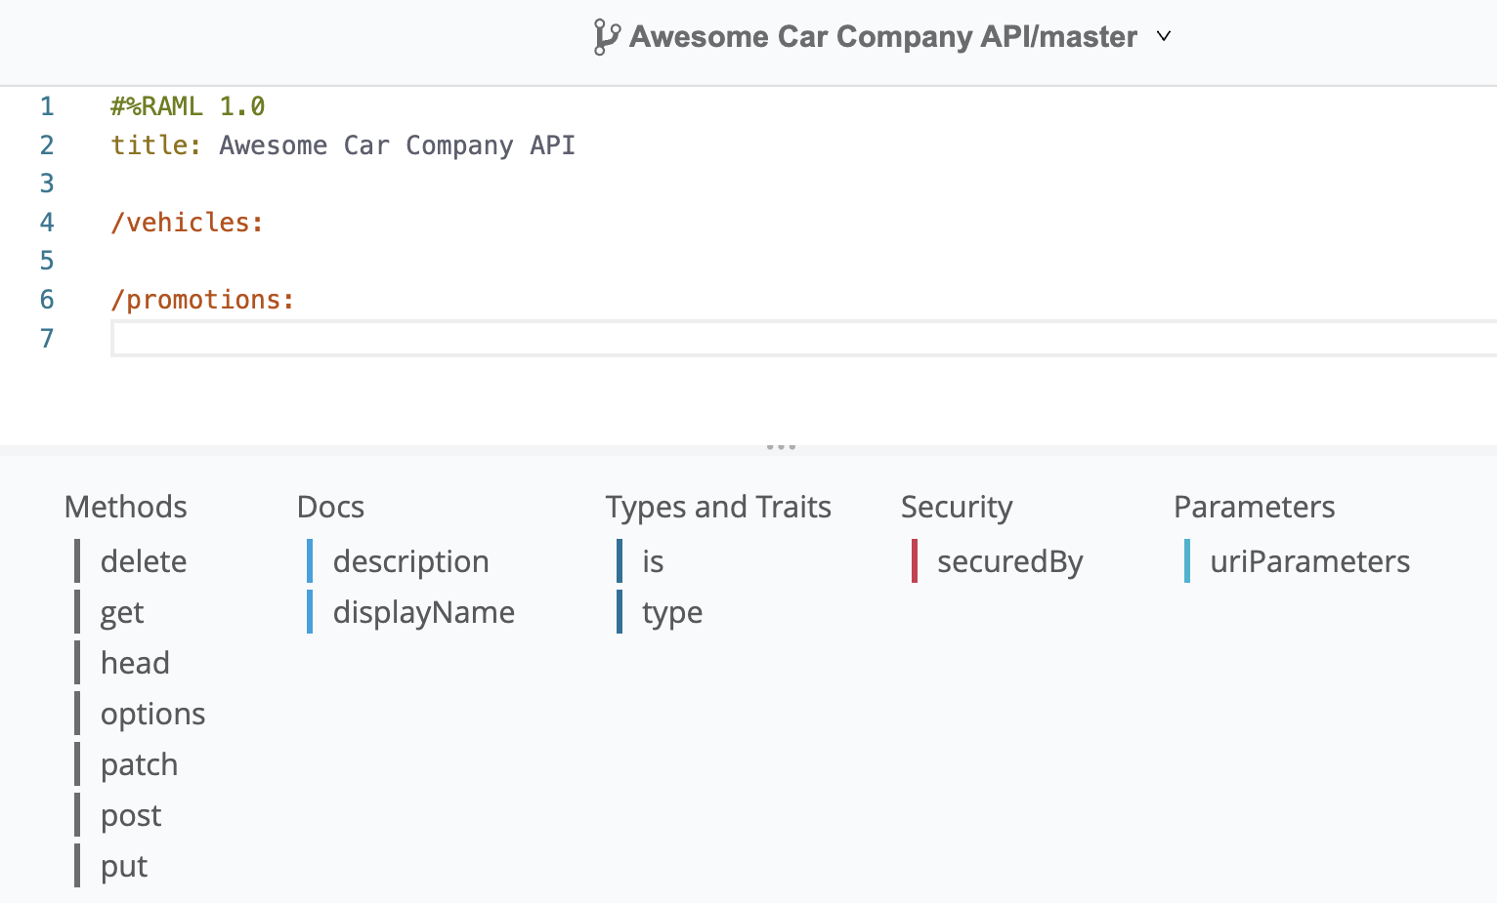

* 1. Click the **get** method in the shelf.
  2. Look at the API console; you should see a GET method for the promotions resource.

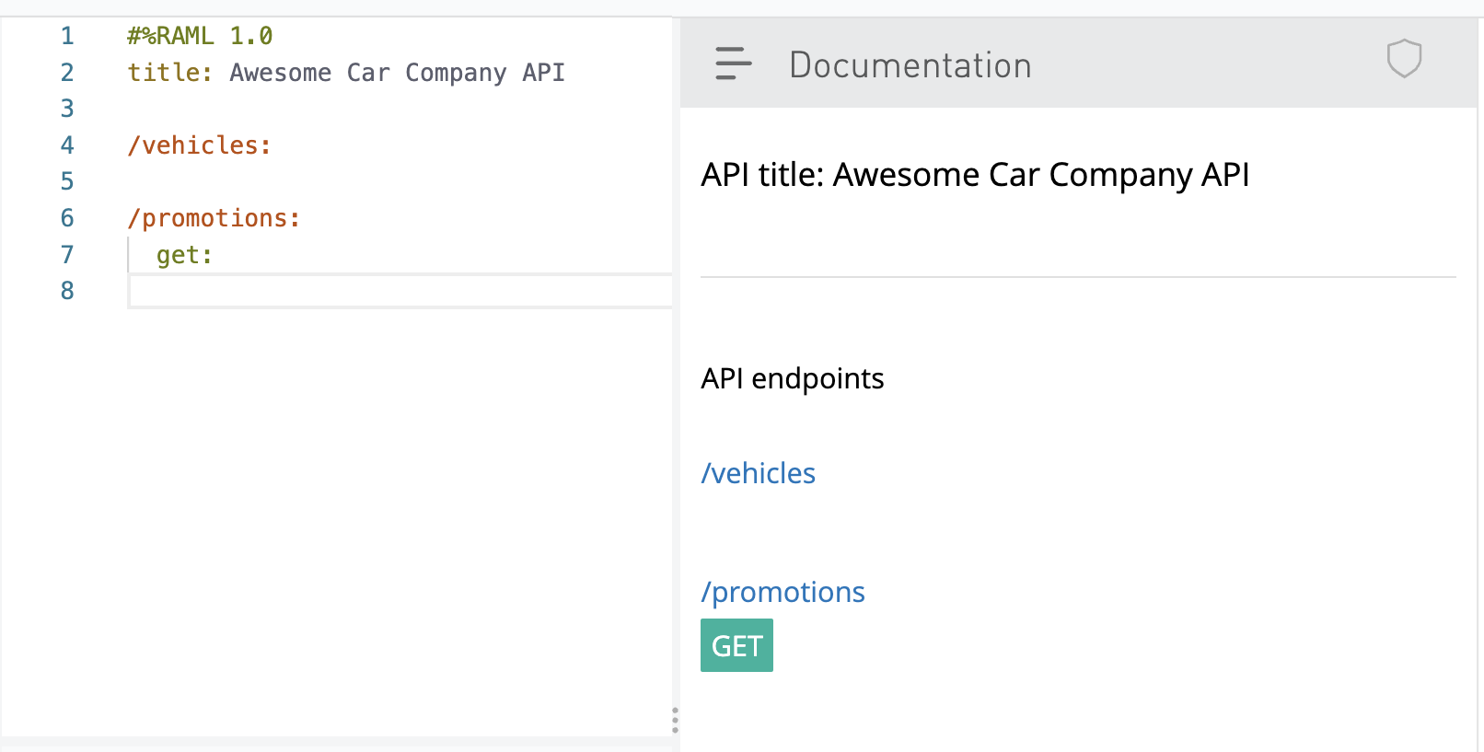

1. Add nested RAML resources
   1. Add a nested resource for vehicles with a particular vehicle identification number by appending the vin to the end of the resource: **/vehicles/{vin}:**
   2. Add a get method to this resource by adding a new line and clicking the **get** method in the shelf.
   3. Add a new line and backspace until you are under the **get** method in the resource above.
   4. Add a service path: **/service:**
   5. Add a **post** method by adding a new line and clicking the **post** method in the shelf.
   6. Add two new lines after the **get** method for the promotions resource and backspace until you are under the promotions resource (at the same indentation as the **get** method).
   7. Add a nested resource for a promotion with a particular code and parts: **/{code}/parts:**
   8. Add a new line and click the **get** method in the shelf.
   9. Compare your API console to the image below; you should see endpoints for all of the nested resources you added.

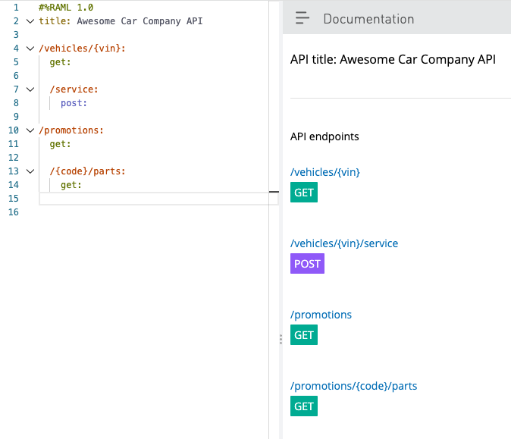

# Exercise 1-2: Use the mocking service to test an API

**Scenario**:

Test the API with a live simulation, which returns sample API responses.

**Goal**:

Test mocked resources using private and public links.

**Tasks:**

1. Use the API console to make calls to a mocked API.
2. Use a shareable public link to make a call to a mocked API.

**Time:**

15 minutes

**Instructions:**

1. In the API console, click the **GET** method for the **/promotions** resource.
2. Review the information; you should see a mocking service URL.

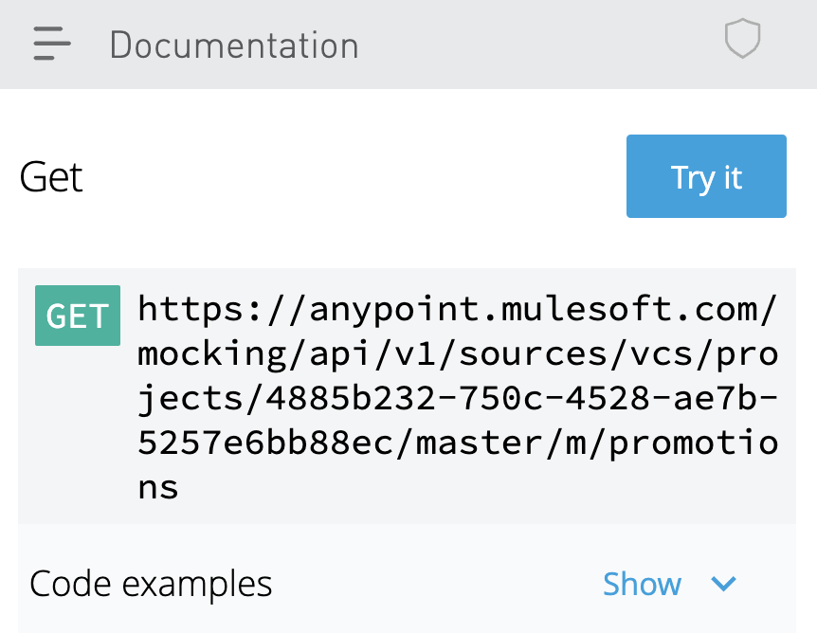

1. Click the **Try it** button for the promotions GET method and then click the **Send** button; you should receive a 200 status code and an empty response.
2. Test the /vehicles/{vin} resource.
   1. Click the menu button located in the upper left of the API console and select **Summary** to return to the resources list.
   2. Click the **GET** method for the **/vehicles/{vin}** nested resource.
   3. Click **Try it** and then click the **Send** button; you should receive a 400 status code with a message that the vin parameter is missing.
   4. In the vin text field, enter a value of **1234567** and click **Send**.
   5. You should receive the same 200 status code and an empty response.
3. Test the /vehicles/{vin}/service:post resource through a shareable link.
   1. Click the Mocking Service Configuration icon  in the right column.
   2. Click the **Make Public** slider to turn it on.
   3. Check the **Set expiration date for public link** checkbox.
   4. Click the calendar icon in the Expiration date field and select a date for next week.
   5. Click the **Copy** button to copy the public link.
   6. Launch Advanced REST Client, paste the copied link, and append it with **/promotions.**
   7. Add a header called **Accept** with a value of **application/json** using the header dropdown menus.
   8. Ensure the method is set to **GET** and click **Send**; you should receive a 200 status code and an empty response.
   9. Return to your Awesome Car Company API in API Designer.
   10. Click the **Make Public** slider to turn it off.
   11. Return to Advanced REST Client and click **Send** again; you should receive a 404 status code.

# Exercise 1-3: Add request and response details

**Scenario**:

Awesome Car Company needs to finish building out the API spec by adding data types, defining method requests and responses, and adding example JSON.

**Goal**:

Define request and response data types along with example JSON.

**Tasks:**

1. Add data types and use them to define method requests and responses.
2. Add example JSON requests and responses.
3. Test an API and get example responses.

**Time:**

90 minutes

**Instructions:**

1. Define data types for the API.
   1. In the file browser, click the add button and select **New folder**.
   2. In the Add new folder dialog box, set the name to **types** and click **Create**.
   3. Click the three dots for the types folder and select **Import**.
   4. In the Import file(s) dialog box, leave **File or ZIP** selected and click the **Choose file** button.
   5. Select **studentfiles/types.zip**, and click **Open**.
   6. In the Import file(s) dialog box, click **Import**.
   7. In the file browser, click the **types** folder and review the imported files.
   8. Return to **awesome-car-company-api.raml** by clicking the root file.
   9. Add two empty lines between the **title** and the **/vehicles** resource and click **types** in the shelf.
   10. Indent under types and add a type called **Part**.
   11. Add an **!include** statement and then add the path to the part.raml file in the types folder.

Part: !include types/part.raml

**NOTE:** *You can also add the path by navigating through the types folder in the shelf.*

* 1. Perform the same process for the **promotion.raml**, **service.raml**, and **vehicle.raml** files in the types folder.

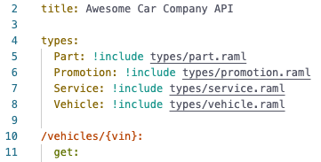

1. Specify the response type for each method.
   1. Add a new line of code at the end of the /vehicles/{vin} get method.
   2. In the shelf, click **responses** > **200** > **body** > **application/json** > **type** > **Vehicle**.

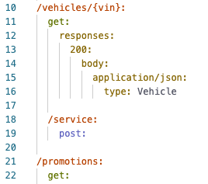

* 1. Add a new line of code at the end of the /vehicles/{vin}/service post method.
  2. In the shelf, click **body** > **application/json** > **type** > **Service**.
  3. Add another new line of code, backspace until you are under **body:**, and add the response type.
  4. In the shelf, click **responses** > **201** > **body** > **application/json** > **type** > **Service**.
  5. Add a new line of code at the end of the /promotions get method.
  6. In the shelf, click **responses** > **200** > **body** > **application/json** > **type**, and type **Promotion[]**.
  7. Add a new line of code at the end of the **/promotions/{code}/parts** get method.
  8. In the shelf, click **responses** > **200** > **body** > **application/json** > **type** >, and type **Part[]**.

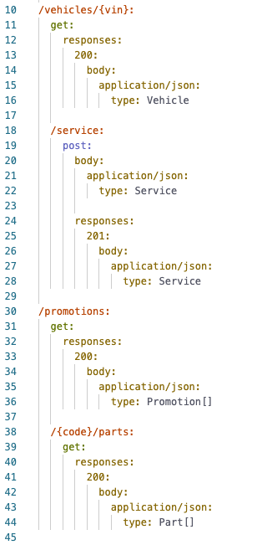

1. Add example responses for each method.
   1. In the file browser, click the add button  and select **New folder**.
   2. In the Add new folder dialog box, set the name to **examples** and click **Create**.
   3. Click the three dots for the examples folder and select **Import**.
   4. In the Import file(s) dialog box, leave **File or ZIP** selected and click the **Choose file** button.
   5. Select **studentfiles/examples.zip**, and click **Open**.
   6. In the Import file(s) dialog box, click **Import**.
   7. In the file browser, click the **examples** folder and review the imported files.

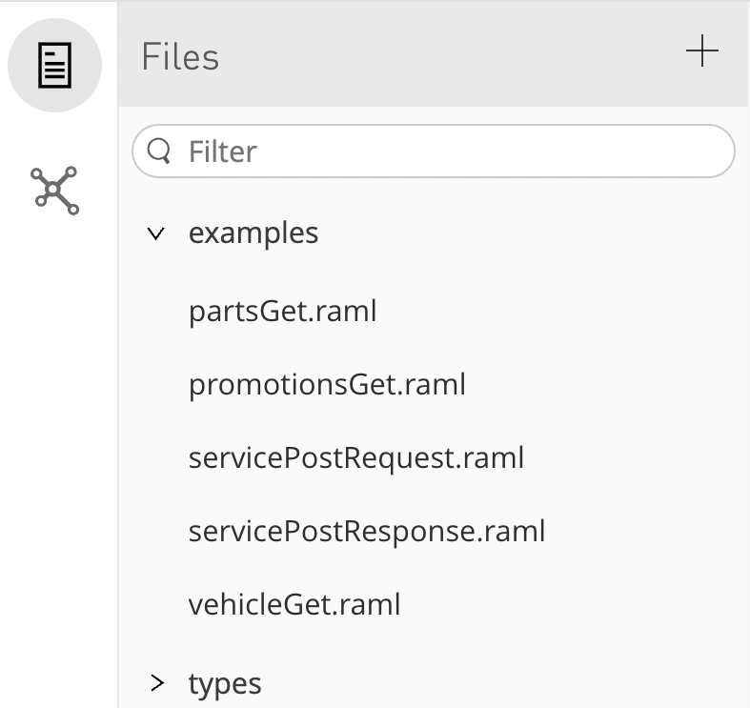

* 1. Return to **awesome-car-company-api.raml** by clicking the root file.
  2. Add a new line after the Vehicle type declaration in the /vehicles/{vin}:get 200 response (at the same indentation as type).
  3. In the shelf, click **examples**, add an **!include** statement, and then click **examples** > **vehicleGet.raml.**
  4. Add a new line after the Service type declaration in the /vehicles/{vin}/service:post body (at the same indentation as type).
  5. In the shelf, click **examples**, add an **!include** statement, and then click **examples** > **servicePostRequest.raml**.
  6. Add a new line after the Service type declaration in the /vehicles/{vin}/service:post 201 response (at the same indentation as type).
  7. In the shelf, click **examples**, add an **!include** statement, and then click **examples** > **servicePostResponse.raml**.
  8. Add a new line after the Promotion[] type declaration in the /promotions:get 200 response (at the same indentation as type).
  9. In the shelf, click **examples**, add an **!include** statement, and then click **examples** > **promotionsGet.raml**.
  10. Add a new line after the Part[] type declaration in the /promotions/{code}/parts:get 200 response (at the same indentation as type).
  11. In the shelf, click **examples**, add an **!include** statement, and then click **examples** > **partsGet.raml**.

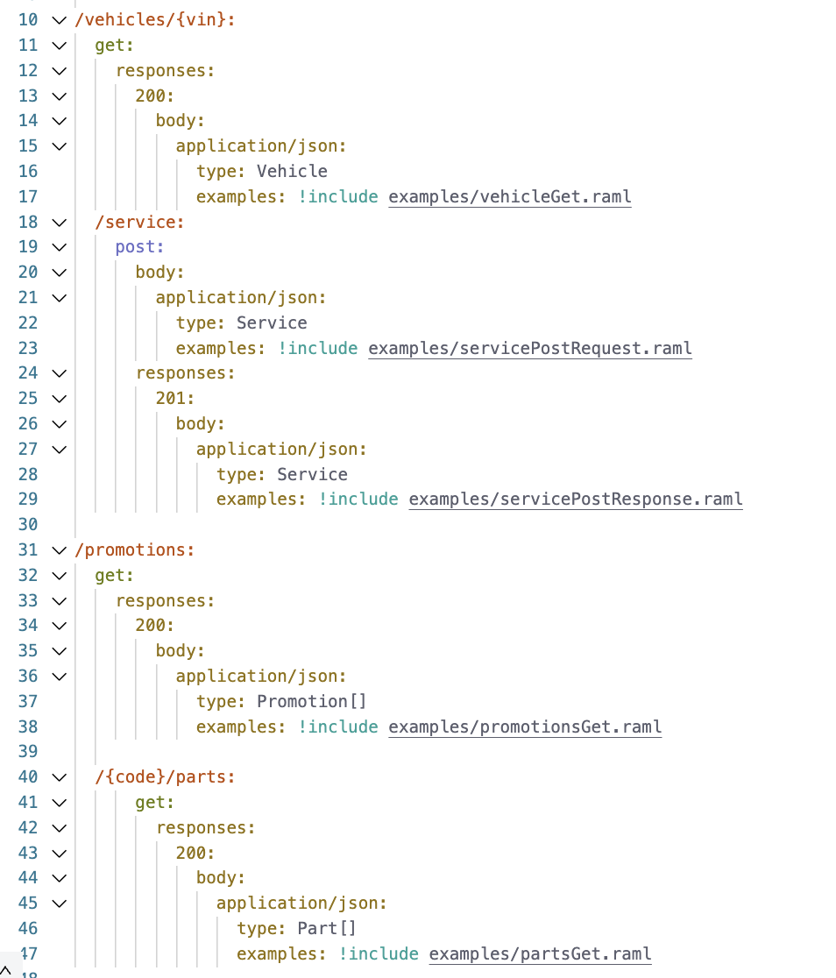

1. Review and test the /promotions:get resource in the API console.
   1. In the API console, click the **/promotions:get** method.
   2. In the response information, look at the type information and ensure you see the example array of Promotion objects.
   3. Click the **Try it** button and click **Send**; you should see a 200 response with two promotions.

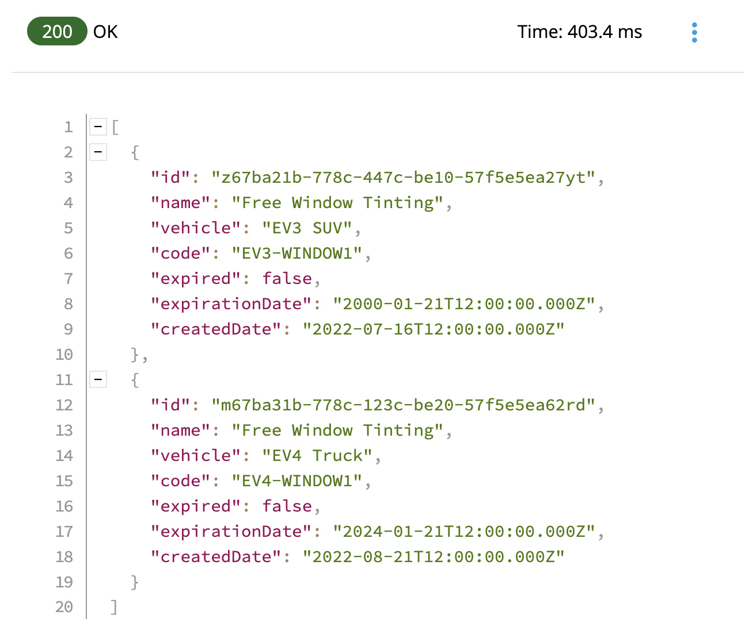

1. Review and test the /vehicles/{vin}:get resource in the API console.
   1. In the API console, click the **/vehicles/{vin}:get** method; you should now see the response is of type Vehicle.
   2. In the response information, ensure you see the example Vehicle data.
   3. Click the **Try it** button, enter **4Y1SL65848Z411439** for the vin, and click **Send**; you should get a 200 response with the example vehicle data.

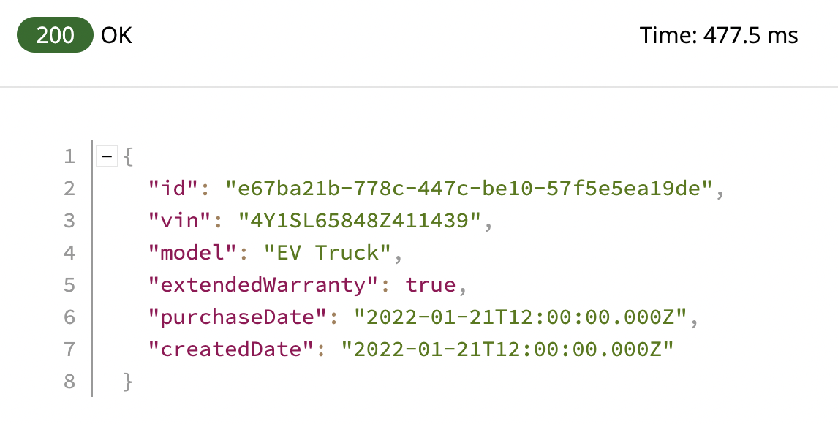

1. Review and test the /vehicles/{vin}/service:post resource in the API console.
   1. In the API console, click the **/vehicles/{vin}/service:post** method.
   2. Look at the request information; you should see information about the body, including the Service type and example data.

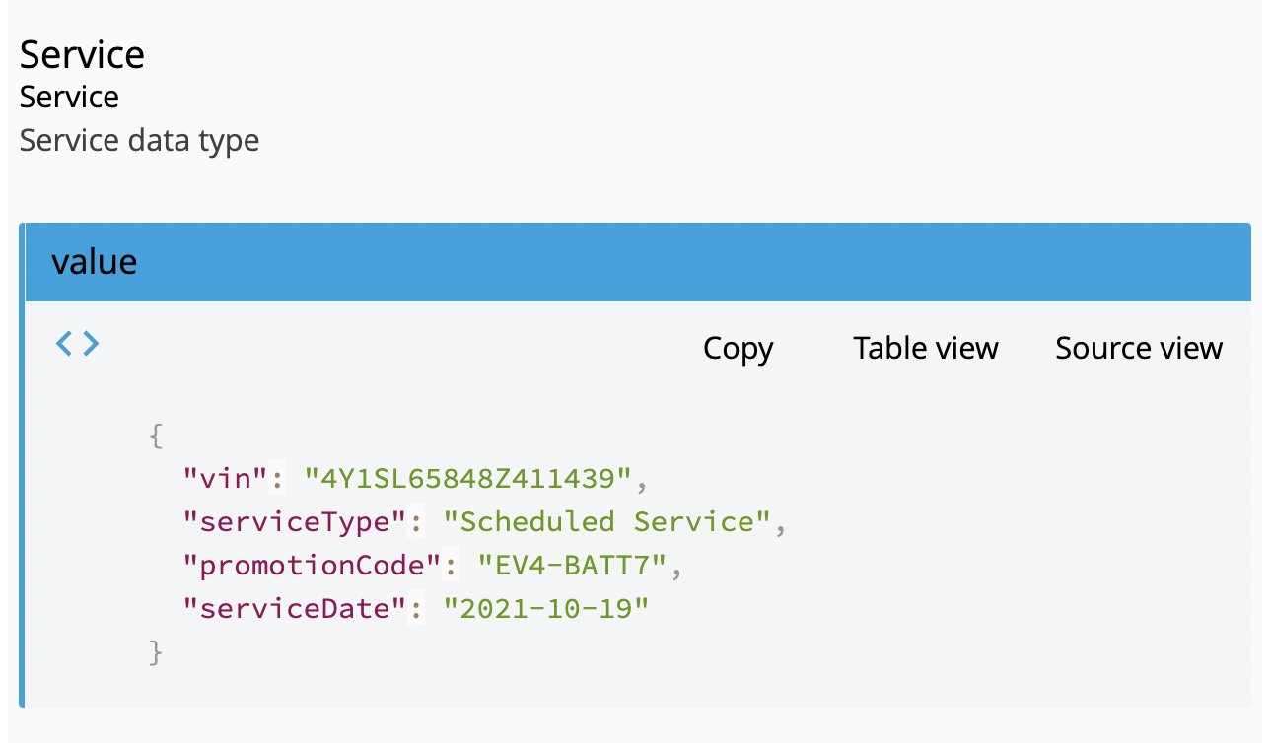

* 1. Click the **Try it** button, enter **4Y1SL65848Z411439** for the vin, and click **Send**; you should get a 201 response with the example data.

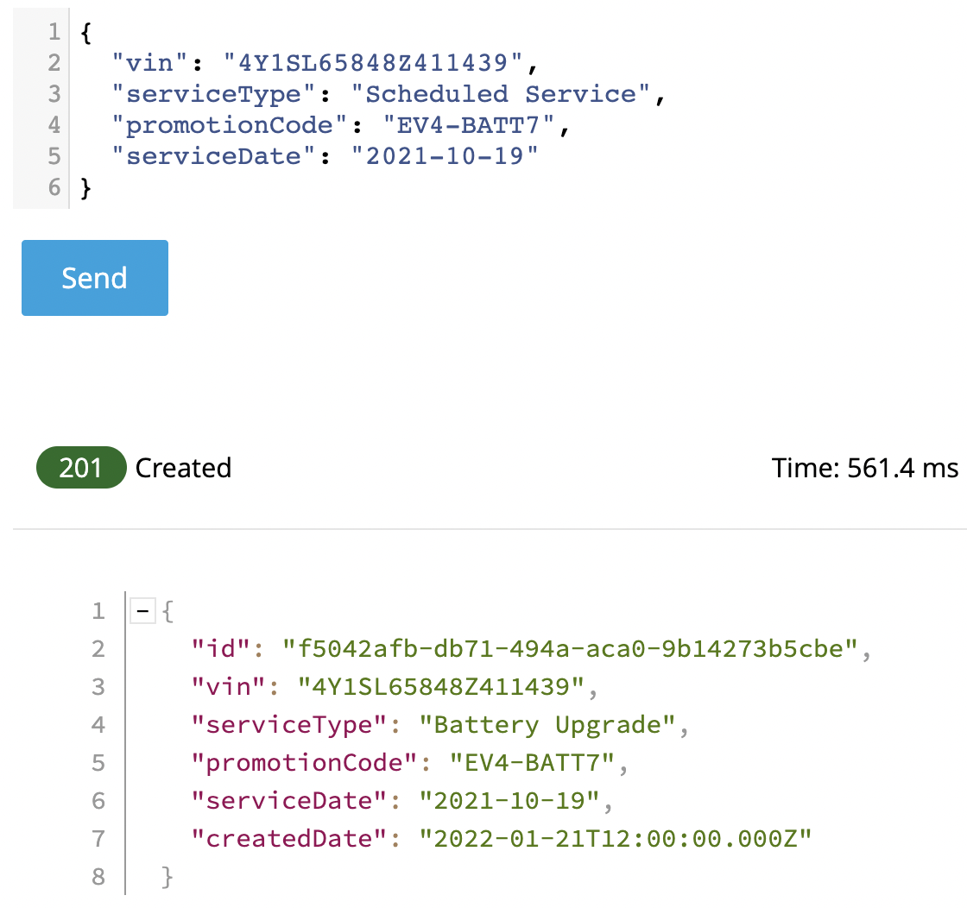

* 1. In the body, remove the vin property, and then click **Send** again; you should see a 400 Bad Request response and a message that the vin parameter is missing.

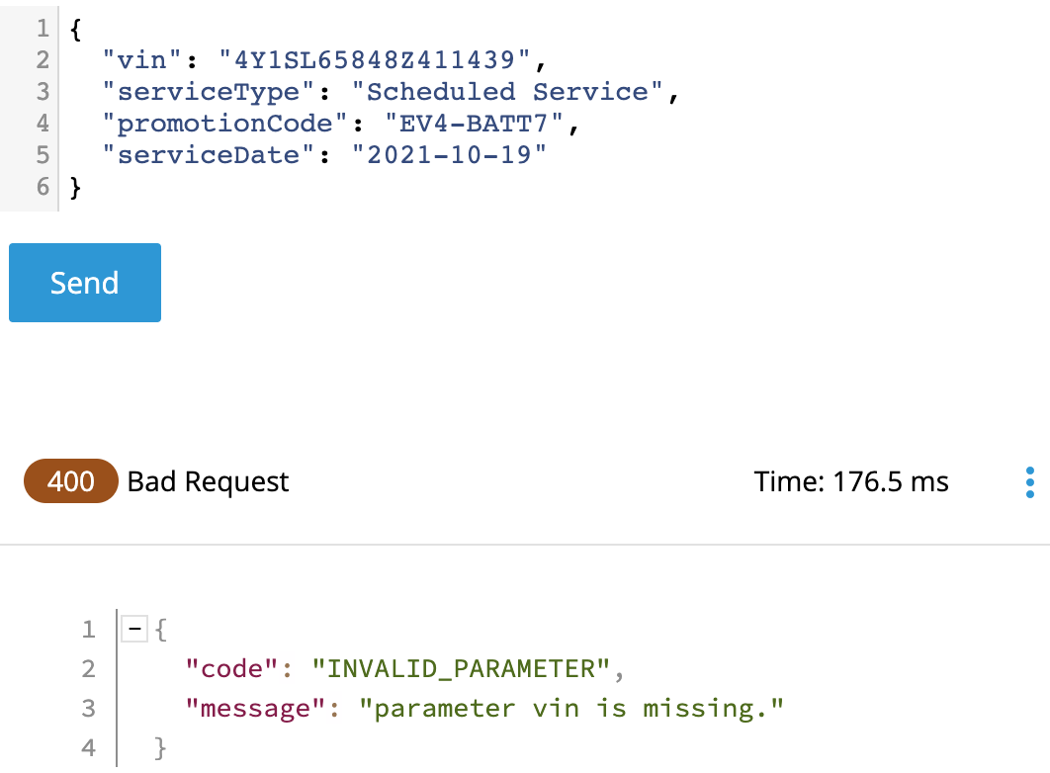

* 1. Add the vin property back to the body.

# 

# Exercise 1-4: Add an API to Anypoint Exchange

**Scenario**:

Engaging with users is an important part of the API design process. Awesome Car Company wants to publish the API to Exchange and create an API portal for feedback.

**Goal**:

Publish and test an API in Anypoint Exchange.

**Tasks:**

1. Publish an API to Exchange from API Designer.
2. Review an auto-generated API portal in Exchange and test the API.
3. Add information about an API to its API portal.

**Time:**

30 minutes

**Instructions:**

1. Publish the API to Anypoint Exchange from API Designer.
   1. Click the **Publish** button.
   2. In the Publishing to Exchange dialog box, set the following values:
      * Asset version: **1.0.0**
      * API version: **v1**
   3. Click the **Advanced options** arrow and examine the values.
   4. Click **Publish to Exchange**.
   5. In the dialog box, click **Close** after the publishing is complete.
2. Locate your API in Anypoint Exchange.
   1. In the main menu, select **Exchange**; you should see your Awesome Car Company API.

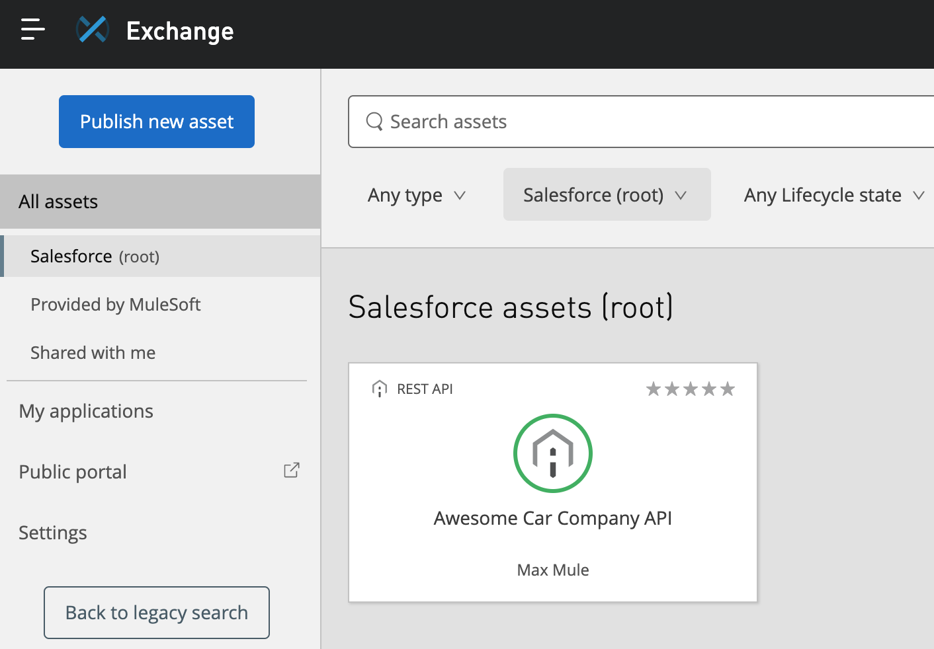

* 1. In the left-side navigation, select **Provided by MuleSoft**; you should *not* find your Awesome Car Company API in the public Exchange.

1. Review the auto-generated API portal.
   1. In the left-side navigation, select the name of your organization (it contains **root**) and then click the **Awesome Car Company API**.
   2. Review the page; you should see that, as the creator of this API, you can edit, review, share, download, and add tags to this version.

**NOTE:** *If the Asset Detail Page dialog box appears, close it.*

* 1. Locate the API version (v1) and minor version (1.0.x) at the upper right of the page.
  2. Click the **Manage Versions** button; you should see that one version (1.0.0) of this API specification has been published for the minor version and one API instance uses the mocking service.
  3. Click **Close**.
  4. In the left-side navigation, select **API instances**; you should see information for the API instance generated from the API specification using the mocking service.

1. Test the API in its API portal in Exchange.
   1. In the left-side navigation, select the **/promotions GET** method; you should now see the API console on the right side of the page.
   2. Click **Send**; you should get a 200 response and the example data displayed, just as you did in the API console in API Designer.
2. Add information about the API.
   1. In the left-side navigation, select **Home**.
   2. Click the **Edit** **documentation** button for the API near the center.
   3. Open the **studentfiles/snippets.txt** file and copy the Awesome Car Company API description text.
   4. Return to the editor in Exchange and paste the content.
   5. Click the **Save** button; you should now see buttons to discard the draft, exit the draft, or publish it.
   6. Click the **Publish** button; you should see the new information about the API in the API portal.

# 

# Exercise 1-5: Share an API

**Scenario**:

Awesome Car Company is ready to start soliciting feedback from both internal and external developers on the API’s usability and functionality. Share the API to both a private and public portal.

**Goal**:

Share an API privately within an organization and publicly to external developers.

**Tasks:**

1. Share an API within an organization using the private Exchange.
2. Create a public API portal.
3. Explore a public portal as an external developer.

note

**Time:**

30 minutes

**Instructions:**

1. Share the API in the private Exchange with others.
   1. Return to your Awesome Car Company API in Exchange.
   2. Click **Share**.
   3. In the Share dialog box, notice that you are an Admin for this API.

**NOTE:** *To share internally with other users and/or teams, simply choose the user or team, set the appropriate permission, and click Save.*

* 1. Click **Cancel**.

1. Create a public API portal.
   1. Click the **Share** button for the API again.
   2. In the Share dialog box, click the **Public** tab.
   3. Select the checkbox next to **v1** to share that version of the API.
   4. Click **Save**.
2. Explore a public portal as an external developer.
   1. Click the **Back to assets list** link.
   2. In the left-side navigation, click **Public portal** and then copy the portal URL after the page loads.
   3. Open a new private or incognito window in your browser, and then paste the portal URL; you should see the public portal *without* the customize button.
   4. Click the **Awesome Car Company API** and explore the portal.
   5. Make a call to one of the resource methods.

# Exercise 2-1: Create a Mule application with Anypoint Studio

**Scenario:**

With the API specifications complete, it is now time to work on the actual implementation. Awesome Car Company wants to create a new Mule application and start configuring endpoints.

**Goal:**

Start the implementation of the API specification by creating a new Mule application and adding an endpoint.

**Tasks:**

1. Create a new Mule project with Anypoint Studio.
2. Add a connector to receive requests at an endpoint.
3. Set the event payload.
4. Run a Mule application using the embedded Mule runtime.
5. Make an HTTP request to the endpoint using Advanced REST Client.

**Time:**

30 minutes

**Instructions:**

1. Create a Mule project.
   1. Open Anypoint Studio.
   2. In the Package Explorer, select **Create a Mule Project**.
   3. In the New Mule Project dialog box, set the Project Name to **awesome-car-company-api**.
   4. Ensure the runtime is set to the latest version of Mule.
   5. Click **Finish**.
2. Create an HTTP connector endpoint to receive requests.
   1. In the Mule Palette, select the **HTTP** module.
   2. Drag the **Listener** operation from the Mule Palette to the canvas.

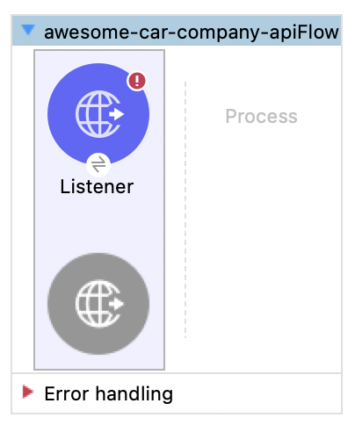

* 1. Change the name of the flow from awesome-car-company-apiFlow to **getPromotions** by clicking on the name at the top of the flow and updating the Name field.
  2. Click the Listener icon.
  3. In the properties view that opens at the bottom of the window, click the green **Add** button next to connector configuration.
  4. In the Global Element Properties dialog box, verify the following default values are present.
     1. Host: 0.0.0.0
     2. Port: 8081
  5. Click **OK**.
  6. In the Listener properties view, set the path to **/promotions**.
  7. Click the **Apply Changes** button to save the file.

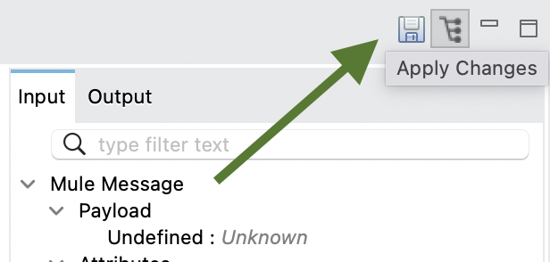

1. Review the HTTP Listener global element.
   1. Select the **Global Elements** tab in the middle of the canvas.
   2. Double-click the HTTP Listener config.
   3. Review the information in the Global Element Properties dialog box.
   4. Click **Test Connection** and ensure the test connection is successful.
   5. Click **OK** and then **Cancel**.
   6. Select the **Message Flow** tab to return to the canvas.
2. Configure the Set Payload transformer.
   1. In the Mule Palette, select **Core**.
   2. Scroll down in the right side of the Mule Palette and locate the Transformers section.
   3. Drag the **Set Payload** transformer from the Mule Palette into the Process section of the flow.

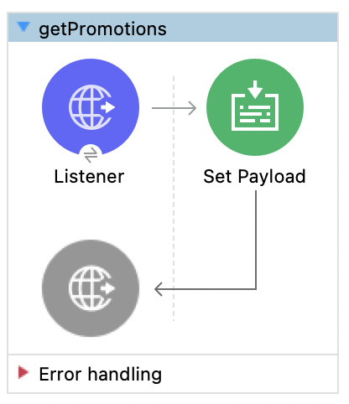

* 1. In the Set Payload properties view, click the **Switch to literal mode** button for the value settings and set the Value field to **All Promotions**.

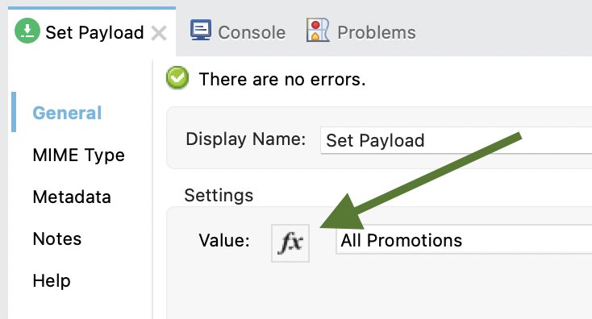

* 1. Select the **Configuration XML** tab at the bottom of the canvas and examine the corresponding XML; you should see the getPromotions Listener at the bottom.
  2. Select the **Message Flow** tab to return to the canvas.
  3. Click the **Save** button or press **Cmd+s** or **Ctrl+s** to save the project.

1. Run the application.
   1. Right-click in the canvas and select **Run project awesome-car-company-api**.

**NOTE:** *If a dialog box appears asking you to accept incoming network connections, click Allow.*

* 1. Watch the Console view; it should display information letting you know that both the Mule runtime and the awesome-car-company-api application started.
  2. Ensure the status is **DEPLOYED**.

1. Test the application.
   1. Return to Advanced REST Client.
   2. Ensure the method is set to **GET** and no headers or body are set for the request.
   3. Make a GET request to http://localhost:8081/promotions; you should see the text **All Promotions** displayed.
   4. Return to Anypoint Studio.
   5. Right-click in the canvas and select **Stop project awesome-car-company-api**.

# Exercise 2-2: Connect to data

**Scenario:**

Awesome Car Company wants to expose portions of its PostgreSQL database to authenticated users via an API endpoint. Configure a database connector and begin querying data.

**Goal:**

Configure a PostgreSQL connector and query data from the database.

**Tasks:**

1. Configure a Database connector that connects to a PostgreSQL database.
2. Configure the Database Select operation to use that Database connector.
3. Write a query to select data from a table in the database.

**Time:**

30 minutes

**Instructions:**

1. Add a Database connector.
   1. Return to Anypoint Studio.
   2. Right-click the Set Payload message processor and select **Delete**.
   3. In the Mule Palette, select **Add Modules**.
   4. Drag the Database connector in the right side of the Mule Palette and drop it into the left side.

**NOTE:** *If you receive a Select module version dialog box, select the latest version and click* ***Add****.*

* 1. Locate the new Database connector in the Mule Palette.
  2. Drag and drop the **Select** operation in the Process section of the flow.

1. Configure a PostgreSQL Database connector.
   1. In the Select properties view, click the **Add** button next to connector configuration.
   2. In the **Connection** type dropdown menu, select **Generic Connection**.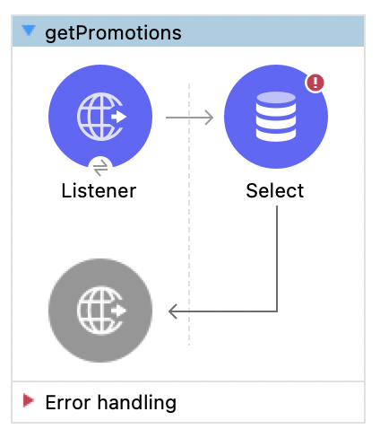
   3. Click the **Configure** button to add the JDBC driver and select **Add Maven dependency**.
   4. Enter **postgresql** in the search field and select **org.postgresql:postgresql:42.5.4**.
   5. Click **Finish**.
   6. Add the values from the snippets.txt file for the URL, Driver class name, User, and Password.
   7. Click the **Test Connection** button; you should get a successful test dialog box.
   8. Click **OK**.
2. Write a query to return all promotions.
   1. In the Select properties view, add a query to select all records from the promotions table in the SQL Query Text input:

SELECT * FROM promotions

1. Test the application.
   1. Save the project and run it.
   2. Watch the console and wait for the application to start.
   3. After the application has started successfully, return to the Advanced REST Client.
   4. Make another request to http://localhost:8081/promotions; you should receive a 500 status code with an invalid data message.

# Exercise 2-3: Transform data

**Scenario:**

Data from the database needs to be compatible with a JSON API. Use DataWeave to transform database records into a JSON response payload.

**Goal:**

Transform the data returned from the database into JSON.

**Tasks:**

1. Use the Transform Message component.
2. Use the DataWeave visual mapper to change the response to a different JSON structure.
3. Create and use a global variable for the JSON structure.

**Time:**

30 minutes

**Instructions:**

1. Add a Transform Message component.
   1. In the Mule Palette, select **Core** and locate the **Transform Message** component in the Components section.
   2. Drag the Transform Message component and drop it after the Select processor.
2. Review metadata for the transformation input.
   1. In the Transform Message properties view, look at the input section and review the payload metadata.

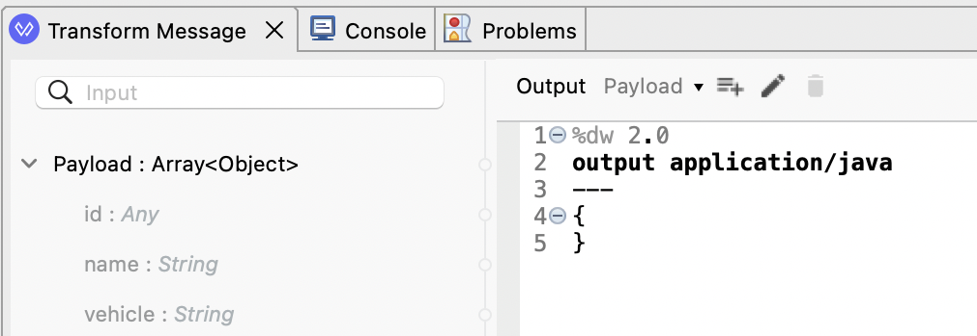

1. Return the payload as JSON.
   1. In the Transform Message properties view, change the output type from **application/java** to **application/json** and change **{}** to **payload**.

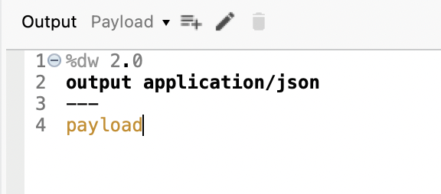

1. Test the application.
   1. Save the file to redeploy the project.
   2. In the Advanced REST Client, send the same request; you should get a 200 response and the promotions data represented as JSON.

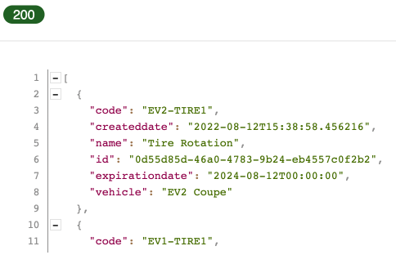

1. Define metadata for the data structure to be returned by the API.
   1. Return to Anypoint Studio.
   2. In the canvas, click the **getPromotions** flow name.
   3. In the properties view, select the **Metadata** tab.
   4. Click the **Add metadata** button.
   5. In the dropdown menu, select **Output: Payload**.
   6. Click the **Edit** icon.
   7. In the Select metadata type dialog box, click the green **Add** icon.
   8. In the Create new type dialog box, set the **Type id** to **promotions_json**.
   9. Click **Create type**.
   10. In the Select metadata type dialog box, set the type to **JSON**.
   11. Change the Schema selection to **Example**.
   12. Click the **browse** button and navigate to the student files.
   13. Select **studentfiles/promotions-example.json** and click **Open**; you should see the example data for the metadata type.

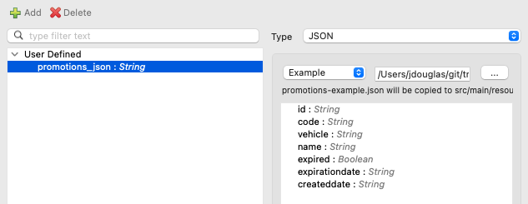

* 1. Click **Select**.
  2. In **getPromotions**, click the **Transform Message** component; you should now see output metadata in the Output section of the Transform Message properties view.

1. Create the transformation.
   1. Map fields with the same names by dragging them from the input section and dropping them on the corresponding field in the Output section.
   2. Change the **expirationdate** and **createddate** output fields to have a capital D for *Date*.

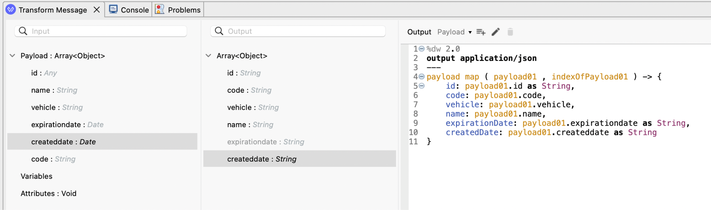

1. Define and use a global variable.
   1. In the header (above output application/json), define a global variable called **expired** that is equal to a lambda expression with an input parameter called **expDate** of type Date.

var expired = (expDate: Date) -> now() > expDate

**NOTE:** *The variable returns a Boolean indicating whether the promotion has expired.*

* 1. Add an **expired** property to the DataWeave expression equal to the expired global variable by passing it the payload’s **expirationdate**.

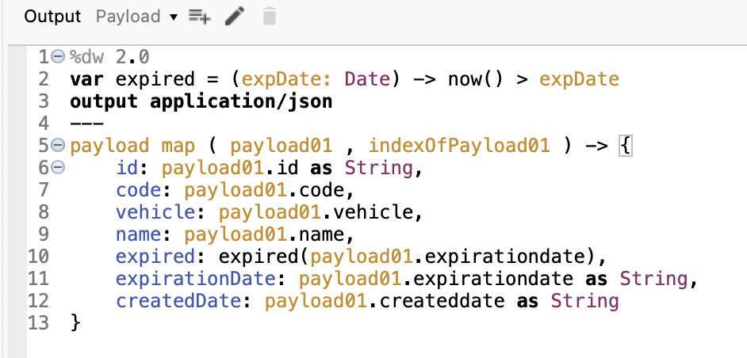

1. Preview sample data and sample output.
   1. In the input section of the Transform Message properties view, right-click Payload and select **Edit Sample Data**; you should see a new tab called payload and it should contain the sample input of type java.
   2. Change the value of the two ID keys from an object to an empty string.

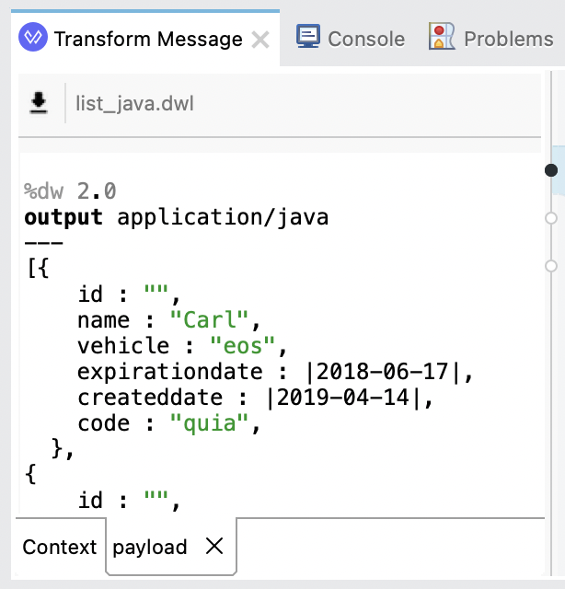

* 1. Click the **Preview** button on the right side of the Transform Message properties view; you should now see values for the **expired** keys.

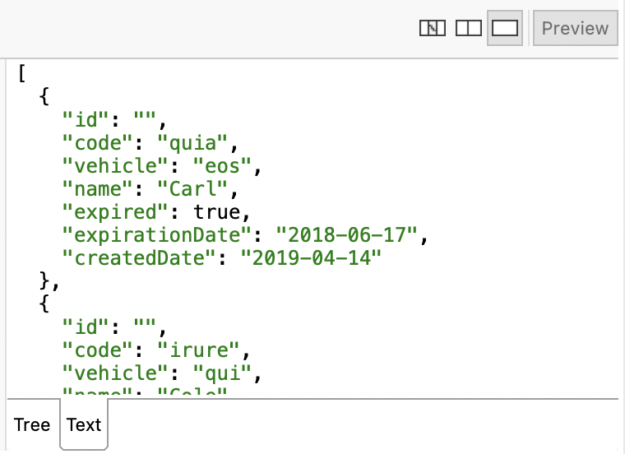

1. Test the application.
   1. Save the file to redeploy the project.
   2. In the Advanced REST Client, send the same request; you should get a 200 response and the promotions data with the new expired JSON key.

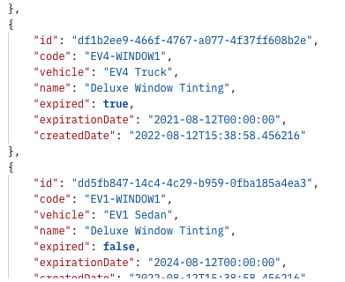

# Exercise 2-4: Create a RESTful interface for a Mule application

**Scenario:**

Awesome Car Company wants to complete the interface for its RESTful API by implementing each resource backed by its database.

**Goal:**

Route requests and use query and payload parameters to operate on data.

**Tasks:**

1. Route based on path.
2. Use a URI parameter in the path of an HTTP Listener.
3. Use URI parameters in a Select operation.
4. Use payload parameters in an Insert operation.

**Time:**

45 minutes

**Instructions:**

1. Restrict method calls to GET.
   1. Select the HTTP Listener in the **getPromotions** flow.
   2. In the left-side navigation of the Listener properties view, select **Advanced**.
   3. Set the **Allowed methods** to **GET**.
2. Create the getPromotionPartsByCode by copying a flow.
   1. Click the getPromotions flow in the canvas to select it.

**NOTE:** *Selecting the flow also selects all of the event source and processors making the copy and paste process more efficient.*

* 1. From the main menu bar, select **Edit** > **Copy**.
  2. Click in the canvas beneath the getPromotions flow and select **Edit** > **Paste**.
  3. Select the new flow and change its name to **getPromotionPartsByCode**.

**NOTE:** *If you want, change the name of the event source and event processors.*

* 1. Select the HTTP Listener in getPromotionPartsByCode.
  2. Modify the path to the following:

/promotions/{code}/parts

1. Modify the Database select.
   1. Click the Select operation in getPromotionPartsByCode.
   2. Change the query to the following:

SELECT parts.id, parts.name, parts.price, parts.number, parts.labor, parts.createddate FROM parts JOIN promotions ON parts.promotion_id = promotions.id WHERE promotions.code = 'EV4-BATT7'

1. Modify the Transform Message.
   1. Select the Transform Message component and modify the output.



* 1. Save the file to redeploy the project.
  2. In the Advanced REST Client, make a request to: http://localhost:8081/promotions/xyz/parts

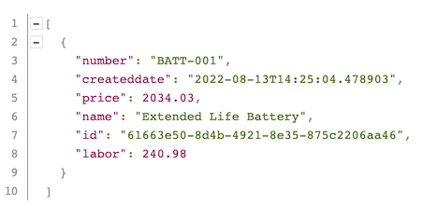

1. Modify the database query to use the URI parameter.
   1. In the Select properties view, locate the Query Input Parameters section, click the Switch to expression mode button, and then add the following.

{ code: attributes.uriParams.code }

* 1. Change the WHERE clause in the SQL Query Text to use the input parameter.

WHERE promotions.code = :code

* 1. Save the file to redeploy the project.
  2. In the Advanced REST Client, make another request to http://localhost:8081/promotions/xyz/parts; you should *not* see any results returned as *xyz* is not a valid part number.

1. Modify the Transform Message.
   1. Click the Transform Message component and modify the output.
   2. Use the map function to iterate through the array of returned records and perform a series of tasks on each.
   3. In this case, rename some of the keys and add a new key to the JSON to return the total cost (price plus labor).

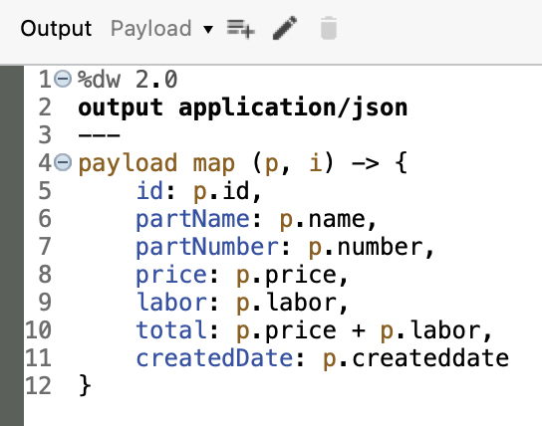

1. Test the application.
   1. Save the file to redeploy the project.
   2. In the Advanced REST Client, make a request to http://localhost:8081/promotions/EV4-BATT7/parts; you should see the following JSON returned.

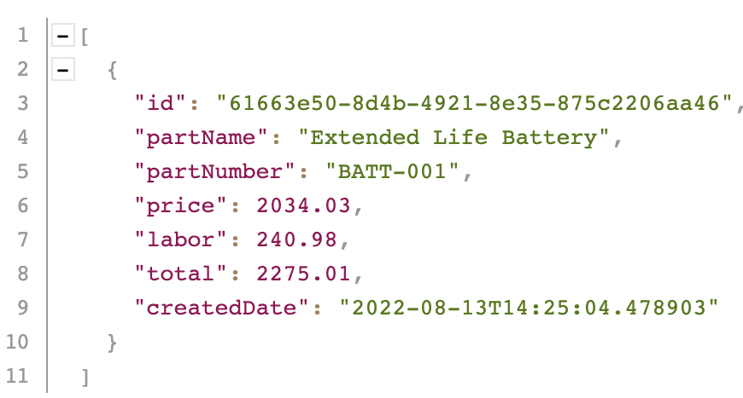

1. Create the getVehicleByVin flow.
   1. Click the getPromotionPartsByCode flow in the canvas to select it.
   2. From the main menu bar, select **Edit** > **Copy**.
   3. Click in the canvas beneath the flow and select **Edit** > **Paste**.
   4. Select the new flow and change its name to **getVehicleByVin**.
   5. Select the HTTP Listener in getVehicleByVin and modify the path to /vehicles/{vin}
2. Modify the Database select.
   1. Click the Select operation in getVehicleByVin.
   2. In the Select properties view, modify the query:

SELECT * FROM vehicles WHERE vin = :vin

* 1. In the Query Input Parameters section, click the Switch to expression mode buttonand then add the following:

{ vin: attributes.uriParams.vin }

1. Modify the Transform Message component.
   1. Click the Transform Message component and modify the output.

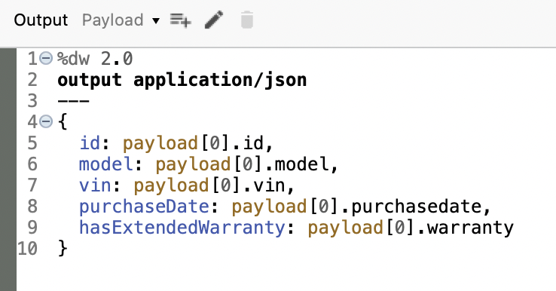

1. Test the application.
   1. Save the file to redeploy the project.
   2. In the Advanced REST Client, make a request to http://localhost:8081/vehicles/4Y1SL65848Z411439; you should see the vehicle record returned.
2. Create the postVehicleServiceByVin flow.
   1. Click the getVehicleByVin flow in the canvas to select it.
   2. From the main menu bar, select **Edit** > **Copy**.
   3. Click in the canvas beneath the flow and select **Edit** > **Paste**.
   4. Select the new flow and change its name to **postVehicleServiceByVin**.
   5. Select the HTTP Listener in postVehicleServiceByVin and modify the path to /vehicles/{vin}/service
   6. In the left-side navigation of the Listener properties view, select **Advanced** and set the Allowed methods to **POST**.
3. Create the Database insert.
   1. Locate the Database connector in the Mule Palette.
   2. Drag and drop the **Insert** operation in the Process section of the flow *before* the Select processor.
   3. Select the Insert operation.
   4. Click the Connector configuration dropdown menu and select **Database_Config**.
   5. In the SQL Query Text, add the following:

INSERT INTO services (vin, promotioncode, servicetype, servicedate) VALUES (:vin, :promotionCode, :serviceType, :serviceDate)

* 1. In the Query Input Parameters section, click the Switch to expression mode button and then add the following.

{

vin: payload.vin,

promotionCode: payload.promotionCode,

serviceType: payload.serviceType,

serviceDate: payload.serviceDate

}

1. Modify the Database select.
   1. Click the **Select** operation in postVehicleServiceByVin.
   2. In the Select properties view, modify the query:

SELECT * FROM services ORDER BY createddate DESC LIMIT 1

* 1. Remove everything in the Query Input Parameters section.

1. Modify the Transform Message component.
   1. Click the Transform Message component and modify the output.

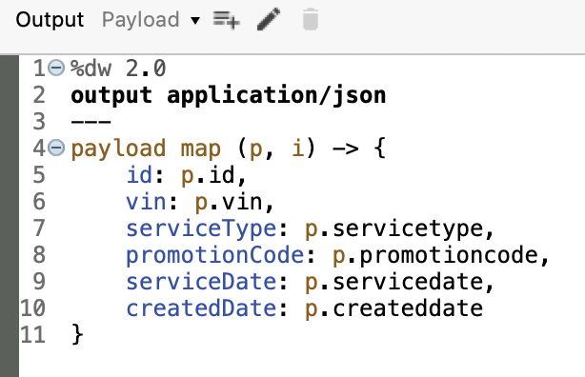

1. Test the application.
   1. Save the file to redeploy the project.
   2. In the Advanced REST Client, ensure the method is set to **POST**.
   3. Click the **Add** button in the Headers section.
   4. Select **Content-Type** in the Header name dropdown menu.
   5. Type **app** in the Header value field and then select **application/json**.
   6. Set the MIME type of the Body section to **JSON** and the body to the following.

{

"vin": "4Y1SL65848Z411439",

"serviceType": "Battery Upgrade",

"promotionCode": "EV4-BATT7",

"serviceDate": "2021-10-19"

}

* 1. In the Advanced REST Client, make a request to http://localhost:8081/vehicles/4Y1SL65848Z411439/service; you should see the following JSON returned.

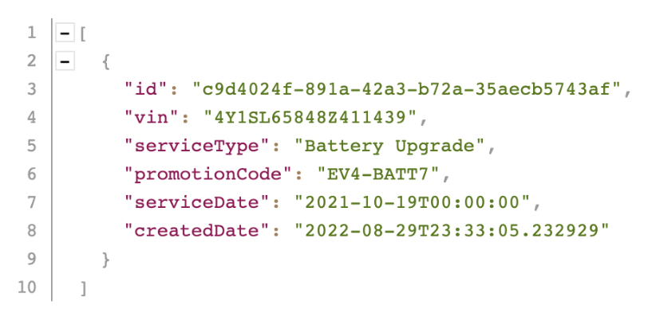

# Exercise 2-5: Deploy an application to CloudHub

**Scenario:**

Time to market is crucial for Awesome Car Company. Instead of provisioning its own infrastructure (servers, firewalls, load balancers, etc.), the company wants to deploy its application to CloudHub, a fully-managed, highly available cloud infrastructure.

**Goal:**

Deploy and run the application on CloudHub with secure endpoints.

**Tasks:**

1. Deploy an application from Anypoint Studio to CloudHub.
2. Run the application on its new, hosted domain.
3. Make calls to the web service.

**Time:**

30 minutes

**Instructions:**

1. Add Anypoint Platform credentials to Anypoint Studio.
   1. Return to Anypoint Studio.
   2. In Package Explorer, right-click the **awesome-car-company-api** project and select **Anypoint Platform** > **Configure Credentials**.
   3. On the Authentication page of the Preferences dialog box, click the **Add** button.
   4. In the User login dialog box, enter your Anypoint Platform username and password and click **Sign In**.
   5. On the Authentication page, make sure your username is listed and selected.
   6. Click **Apply** **and** **Close**.
2. Deploy the application to CloudHub.
   1. Open the project’s **pom.xml** file and set **artifactId** to **awesome-car-company-api-{your-lastname}** so it is a unique value.
   2. Save the file.
   3. In Package Explorer, right-click the project and select **Anypoint Platform** > **Deploy to CloudHub**.
   4. In the Choose Environment dialog box, select **Sandbox**.
   5. At the top of the Anypoint Platform dialog box, set the application name to **awesome-car-company-api-{your-lastname}** so it is a unique value.

**NOTE:** *This name will be part of the URL used to access the application on CloudHub. It must be unique across all applications on CloudHub. The availability of the domain is instantly checked and you will get a checkmark if it is available.*

* 1. Make sure the runtime version is set to the version your project is using.

**NOTE:** *If you don’t know which version it is using, look at Package Explorer and find a library folder with the name of the server being used, like Mule Server 4.4.0 EE.*

* 1. Ensure the **Replica size** is set to **0.1 vCores**.
  2. Click **Deploy Application**.
  3. Click the **Open in Browser** button (you don’t have to wait for your application to fully deploy).
  4. In the Anypoint Platform browser window that opens, locate the status of your deployment in Runtime Manager.

1. Watch the logs and wait for the application to start.
   1. Click in the row of the application (not on its name); you should see information about the application appear on the right side of the window.
   2. Click **Manage application** to go to the application's settings.
   3. Click the **Logs** button in the left menu on the left side of the page and watch the logs as the application deploys.
   4. Wait until the application starts (or fails to start).

**NOTE:** *If your application did not successfully deploy, read the logs to help determine the reason. If you had errors when deploying, troubleshoot them, fix them, and then redeploy.*

1. Test the application.
   1. In the left-side navigation, select **Dashboard**.
   2. Click the link for the application on its new domain; a GET request will be made to that URL in a new browser tab and you should get a message that there is no listener for that endpoint.

**NOTE:** *Switch from HTTPS to HTTP if you receive a Bad Gateway error.*

* 1. Append /promotions to the end of the base URL; you should see a collection of promotions data returned.

**NOTE:** *Copy the base URL of your API. You’ll need it throughout the course.*

# 

# Exercise 2-6: Create and deploy an API proxy

**Scenario:**

Awesome Car Company wants to implement a secure access point to route API requests, aggregate API responses, and enforce service-level agreements. Create and deploy an API proxy to CloudHub to secure and monitor the newly created API.

**Goal:**

Create an API proxy application and deploy it to CloudHub.

**Tasks:**

1. Add an API to API Manager.
2. Use API Manager to create and deploy an API proxy application.
3. Set a proxy consumer endpoint so requests can be made to it from Exchange.
4. View API request data in API Manager.

**Time:**

30 minutes

**Instructions:**

1. Create and deploy a proxy application.
   1. Return to Anypoint Platform.
   2. In the main menu, select **API Manager**; you should see no APIs listed for the Sandbox environment.
   3. Click the **Add API** button and choose **Add new API**.
   4. On the APIs / Add API page, select **Mule Gateway** for the Runtime settings.
   5. Select **Deploy a proxy application** for the proxy type.
   6. Set the rest of the Runtime settings to the following values.
      1. Target type: **CloudHub**
      2. Runtime version: **4.4.0**
      3. Proxy app name: **awesome-car-company-proxy-{your-lastname}**
   7. Click **Next**.
   8. For the API settings, ensure **Select API from Exchange** is selected and then check **Awesome Car Company API** in the Select API section.
   9. Click **Next**.
   10. Set the **Implementation URI** to your API’s URL.
   11. Expand **Advanced options** and examine the additional fields and values.
   12. Click **Next**.
   13. Review the settings and click **Save & Deploy**.

**NOTE:** *If your proxy application does not successfully deploy, read the logs to help determine the reason. If you had errors when deploying, troubleshoot them, fix them, and then redeploy.*

* 1. Click the **Actions** button in the upper right and then click the **View configuration details** link.
  2. Examine the configuration details then click **Dismiss**.
  3. Locate the Proxy URL, right-click it, and copy the link address.
  4. Expand the **Runtime & Endpoint Configuration** section.
  5. Paste the Proxy URL into the **Consumer endpoint**.
  6. Click **Save & Deploy**.
  7. After the deployment is complete, open a web browser and navigate to your Proxy URL; you should see the promotions data.

http://awesome-car-company-proxy- {lastname}.{region}.cloudhub.io/promotions

1. View the new API proxy instance in Exchange.
   1. Click the **Actions** button and then click **View API in Exchange**.
   2. Click the **Manage versions** button to locate the API instances now associated with asset version 1.0.0; you should see the mocking service instance and the new proxy.
   3. Click **Close**.

# Exercise 2-7: Update the API proxy to use HTTPS

**Scenario:**

Awesome Car Company needs to update the API proxy to use HTTPS so that data is encrypted in transit in both directions.

**Goal:**

Create the necessary encryption and update the API proxy application to use HTTPS.

**Tasks:**

1. Create a secret group to store a logical grouping of secrets.
2. Add a keystore to store private keys.
3. Create a TLS context to encrypt traffic.
4. Update an API proxy to use HTTPS.

**Time:**

30 minutes

**Instructions:**

1. Create a secret group.
   1. Return to Anypoint Platform.
   2. In the main menu, select **Management Center** > **Secrets Manager**.
   3. Click the **Design** button in the upper left and switch to the **Sandbox** environment.
   4. Click **Create Secret Group**.
   5. Enter **awesome-car-company-secret-group** for the Name.
   6. Check **Secret Group Downloadable**.
   7. Click **Save**.
2. Generate a keystore file.

**NOTE:** *In order to enable HTTPS for CloudHub, you must generate a keystore JKS file using the JDK keytool utility on the command-line interface. There is a* ***studentfiles/hyperautomation.jks*** *file that you can use instead of generating your own keystore. However, if you do generate your own keystore, ensure that you write down the password and alias you use!*

* 1. Open the command-line interface and type the following command to generate your keystore.jks file.

keytool -genkey -alias {alias-name} -keystore {alias-name}.jks -keyalg RSA -storetype JKS

* 1. Respond to prompts to enter your desired values.

1. Add a keystore.
   1. Return to Anypoint Platform.
   2. Click the **Keystore** link on the left.
   3. Click **Add Keystore**.
   4. Name the Keystore **awesome-car-company-key-store**.
   5. Set **Type** to **JKS**.
   6. For the **Keystore File**, click the **Choose File** button and choose your newly created **\*.jks** file.
   7. For the **Keystore Passphrase**, enter the password that you used to generate the keystore or use the password from the course snippets.txt file.
   8. Select the **Alias** you used from the dropdown menu or use the alias from the course snippets.txt file.
   9. For the **Key Passphrase**, enter the password that you used to generate the keystore or use the password from the course snippets.txt file.
   10. Click **Save**.
2. Add a TLS context.
   1. Click the **TLS Context** link on the left.
   2. Click **Add TLS Context**.
   3. **Name** the TLS context **awesome-car-company-context**.
   4. Expand the **Target** dropdown menu and select **Mule**.
   5. Select **TLS 1.2**.
   6. Expand the Keystore dropdown menu and select **awesome-car-company-key-store**.
   7. Click **Save**.
3. Update the API proxy to use HTTPS.
   1. In the main menu, select **API Manager** and then select **Awesome Car Company API**.
   2. At the bottom, expand the **Runtime & Endpoint Configuration** section.
   3. Select **HTTPS** for **Scheme**.
   4. In the **TLS Context for inbound traffic** setting, click the **Add TLS Context** link.
   5. For the secret group, select **awesome-car-company-secret-group**.

**NOTE:** *If you do not see this group, ensure that the group has Secret Group Downloadable selected and was created in the Sandbox environment.*

* 1. For the TLS context, select **awesome-car-company-context**.
  2. Click **OK**.
  3. Edit the **Consumer endpoint** so that it uses HTTPS.
  4. Click **Save & Apply**.

**REMINDER:** *Copy the secure consumer endpoint as your Proxy URL. You’ll need it throughout the course.*

* 1. After the proxy has been deployed, navigate to https://awesome-car-company-proxy- {lastname}.{region}.cloudhub.io/promotions; you should see the promotions data.

# Exercise 2-8: Secure API access with policies

**Scenario:**

Security best practices require restricting access to endpoints. Awesome Car Company wants to secure the API by requiring users enter a username and password.

**Goal:**

Create an authentication policy to restrict access to the API.

**Tasks:**

1. Create a basic authentication policy.
2. Update an API specification to use policies.

**Time:**

30 minutes

**Instructions:**

1. Create a basic authentication policy.
   1. Return to the **Settings** page for your **Awesome Car Company API** in API Manager.
   2. In the left-side navigation, select **Policies**.
   3. Click **Add policy.**
   4. In **Browse by category**, select **SECURITY**.
   5. Choose the **Basic Authentication - Simple** policy.
   6. Click **Next**.
   7. For the User Name and User Password, enter **mulesoft**.
   8. Click **Advanced options**.
   9. Ensure that the latest version of the policy is selected and that **Apply configuration to all API method & resources** is selected.
   10. Click **Apply**.
   11. In the main menu, select **Runtime Manager** and then select your proxy application.
   12. In the left-side navigation, select **Logs**.
   13. Watch the logs and wait for the policy to be applied.

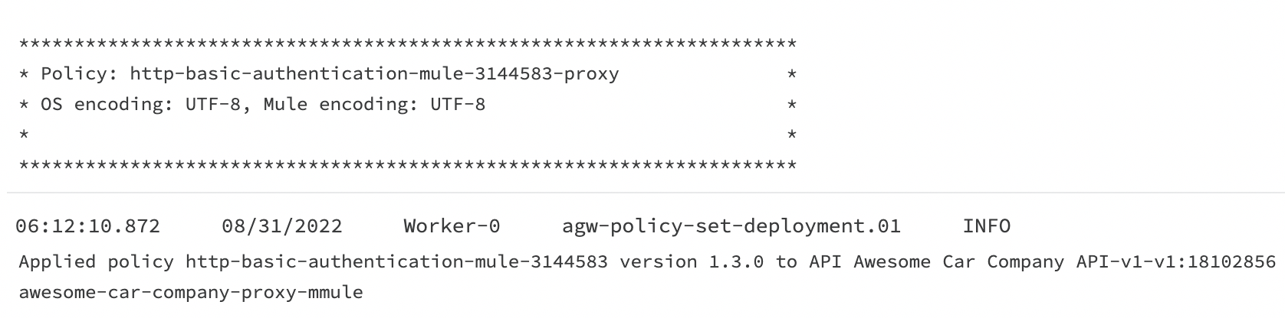

1. Test the application.
   1. Navigate to https://awesome-car-company-proxy- {lastname}.{region}.cloudhub.io/promotions; you should see a modal asking for a username and password.
   2. Enter **mulesoft** as the username and password and click **OK**; you should now see the promotions data.
2. Update the API specification.
   1. In the main menu, select Design Center and then select your **Awesome Car Company API**.
   2. Add two lines of code after the title.
   3. In the shelf, click **securitySchemes**.
   4. Enter **basic:** and add a new line.
   5. In the shelf, click **type** > **Basic Authentication**.
   6. Add two more lines of code and backspace as far as you can.
   7. In the shelf, click **securedBy** > **basic**.
   8. Backspace to remove the semicolon.

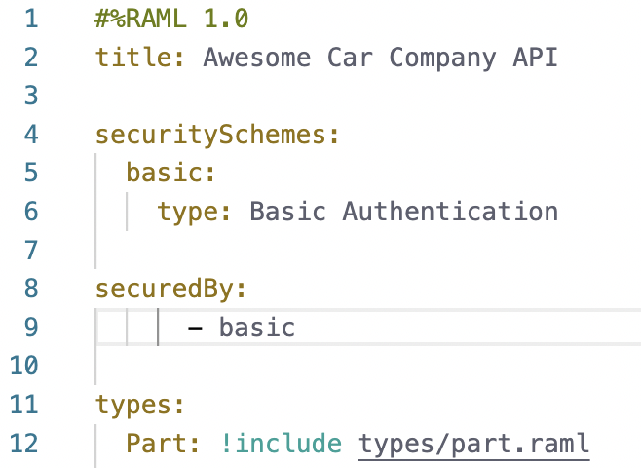

* 1. In the API console, click the **GET** method for the **/promotions** resource; you should now see that it references the Basic Authentication security scheme.
  2. Click the **Try it** button, enter **mulesoft** as the credentials, and then click the **Send** button; you should get a 200 status code and the promotions data.
  3. Click **Publish**.
  4. Verify that the Asset version is **1.0.1**.
  5. Click **Publish to Exchange**.
  6. Click **Close**.

1. Update the proxy application.
   1. In the main menu, select **API Manager** and then **Awesome Car Company API**.
   2. Click the **Actions** button and select **Change API Specification**.
   3. In the Asset Version dropdown menu, select the latest version, **1.0.1 (Latest)**, and click **Change**.
   4. Scroll to the bottom, expand the **Runtime & Endpoint Configuration** section.
   5. Click **Save & Apply**.

# Exercise 3-1: Create and evaluate an RPA process

**Scenario:**

EVs R Us has an idea to utilize RPA to automate the process of looking up rebate amounts from Awesome Car Company’s restricted, internal dealer site. The first step is to evaluate the proposed process to determine if it is even valuable to the company.

**Goal:**

Create a new RPA candidate process and evaluate its benefits and feasibility.

**Tasks:**

1. Create a new RPA process candidate for automation.
2. Evaluate the benefits and feasibility of an automation of a real-life business process.

**Time:**

30 minutes

**Instructions:**

* 1. Log in to RPA Manager.
  2. Select **Process Evaluation** > **Process Evaluation**.
  3. Click **Create**.
  4. Enter **Awesome Car Company Rebate Lookup {lastname}** for the Name.
  5. Click **OK**.
  6. For Manual process execution time, enter **5** minutes.
  7. Set Costs per process run to **$5**.
  8. For Frequency per month, enter **1000**.
  9. For Qualifiers, move the sliders to match the image.

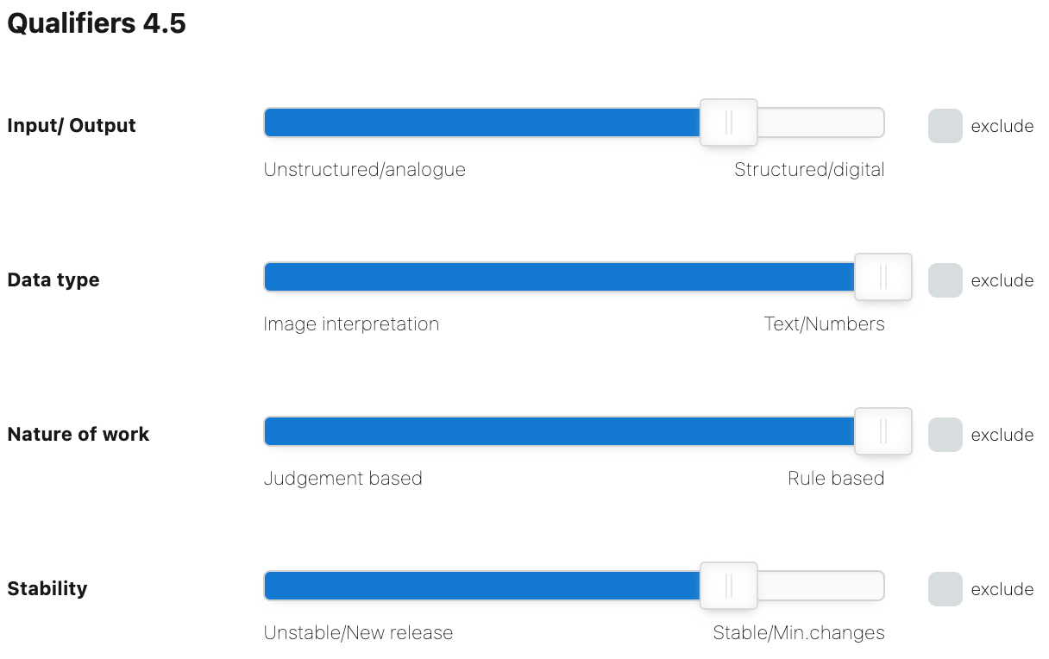

* 1. For Benefits, move the sliders to match the image.

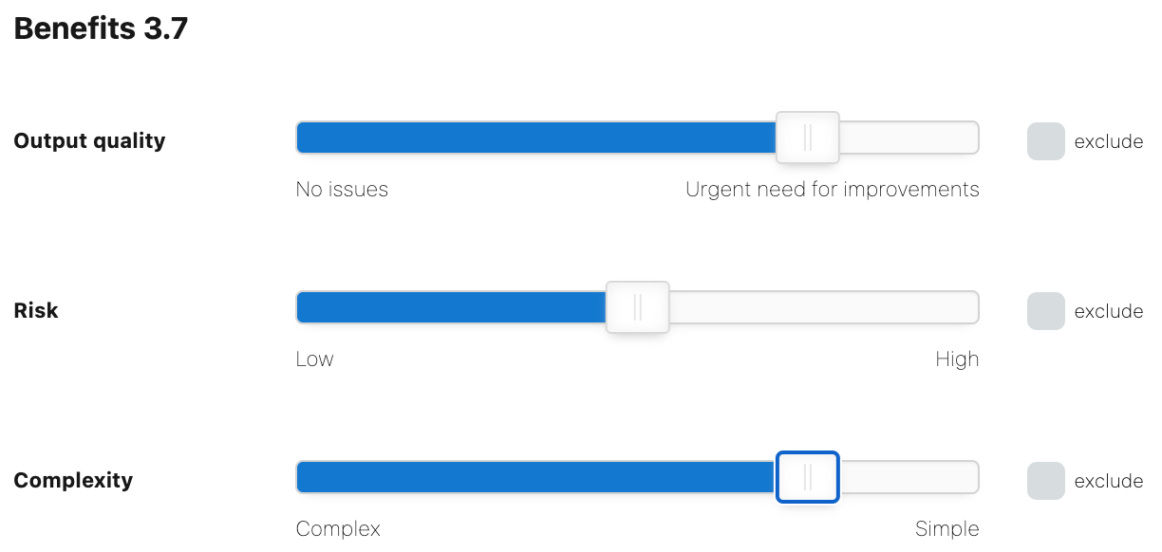

* 1. The Process Matrix plots the Qualifiers versus the Benefits values.

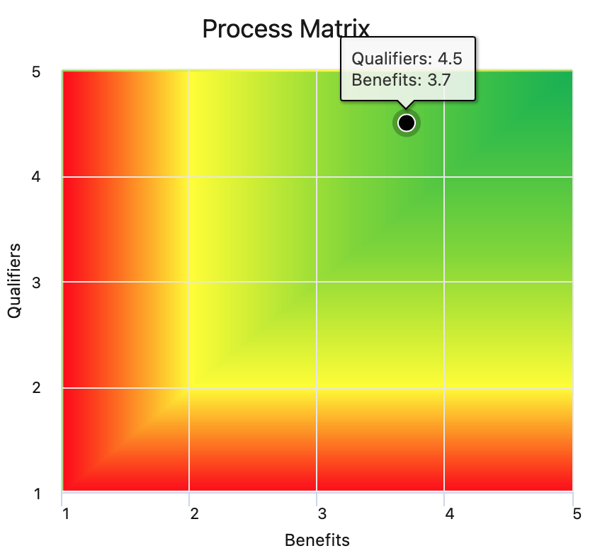

**NOTE:** *The Cost criteria are not an input for the Process Matrix.*

* 1. Click **Save**.
  2. Click the **Approve** icon for the Awesome Car Company Rebate Lookup process.

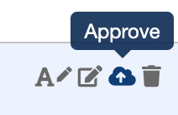

* 1. Select your user as the Project Manager.
  2. Click **OK**.

# Exercise 3-2: Design an RPA process

**Scenario:**

Now that the RPA process has been approved, EVs R Us needs to design the process using RPA Recorder.

**Goal:**

Use RPA Recorder to record the steps to obtain the rebate amount from Awesome Car Company’s private website.

**Tasks:**

1. Move backlog processes to the design phase.
2. Record a process using RPA Recorder.

**Time:**

45 minutes

**Instructions:**

1. Move a process to the design phase.
   1. Select **My RPA** > **My Backlog**.
   2. Click the **Start automation** icon for the Awesome Car Company Rebate Lookup process.

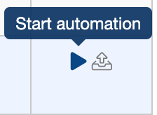

* 1. For your user, select the **Design**, **Build**, **Test** and **Production** boxes.
  2. Select **RPA Training Category** as the category.
  3. Deselect the **Use Process Board** checkbox.
  4. Click **Save**.

1. Record a process using RPA Recorder.
   1. Click the **Open Process** icon for the Awesome Car Company Rebate Lookup process.

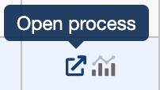

* 1. Click the down arrow on the **Automation** box to expand it, and then click the RPA Recorder button at the bottom.
  2. Click **Open RPA Recorder**, enter your login credentials, and click **Login**.
  3. Minimize the RPA Manager window.
  4. Click the Start Recording button.
  5. Create a new Bot Task activity with the name **Open Rebate Site**, and click **Add**.
  6. Open Firefox and navigate to <https://awesome-car-company.herokuapp.com>.
  7. Click the **Plus** button  in the lower right to add an activity.
  8. Name the activity **Login** and click **Add**.
  9. In Firefox, click the **Please login to continue** link, enter **mulesoft** for both the username and password, and then click the login button.

**NOTE:** *If the Firefox Password Manager model opens, click the red Pause recording button in the lower right, click the OK button in the modal, and then click the red Resume record button so that the Password Manager clicks are not recorded.*

* 1. Click the **Plus** button in the lower right to add an activity.
  2. Name the activity **Navigate to Rebate Page** and click **Add**.
  3. In Firefox, click the **Rebates** link.
  4. Click the **Plus** button in the lower right to add an activity.
  5. Name the activity **Locate Rebate** and click **Add**.
  6. In Firefox, press Ctrl+a to select all of the text on the screen and then Ctrl+c to copy it to your clipboard.
  7. Click the **Stop recording** checkered flag button.
  8. Click the **Edit** buttonin the lower left.
  9. Click the Upload button to upload the recording to RPA Manager.
  10. Click **OK** in the Information box indicating a successful upload.
  11. Exit the RPA Recording Editor.
  12. Exit the RPA Recorder.
  13. Return to the **Awesome Car Company Rebate Lookup** process in RPA Manager and refresh the page; you should see your uploaded recording.
  14. Click each activity, expand the **Documentation** box, and inspect the recording of each activity.
  15. Click **Publish**.
  16. Select the **Confirm** checkbox and click **Release to Build**.

**NOTE:** *The BPMN will display errors because no workflows are bound to the Bot Tasks.*

# Exercise 3-3: Build an RPA process

**Scenario:**

With the design phase complete, EVs R Us now needs to use RPA Builder to build the automations by specifying the steps of the process.

**Goal:**

Use RPA Builder to implement the process to obtain the rebate amount from Awesome Car Company’s private website.

**Tasks:**

1. Set and use activity parameters in an RPA process.
2. Create RPA bot tasks.
3. Refine RPA Recorder auto-generated steps.
4. Configure and use elements for RPA bot task implementations.

**Time:**

120 minutes

**Instructions:**

1. Configure activity parameters.
   1. Launch MuleSoft RPA Builder.
   2. Log in with the RPA Manager address and your RPA Manager credentials.
   3. Select the **Repository Explorer** tab and double-click the **Awesome Car Company Rebate Lookup** process to open it.

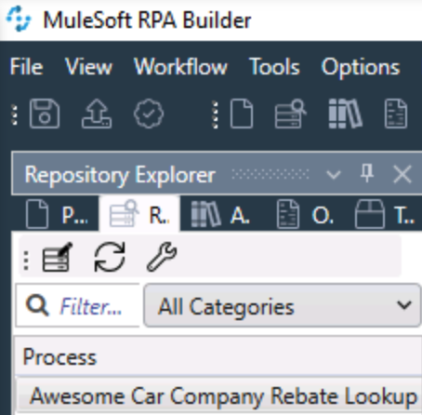

**NOTE:** *Click the Refresh button if you do not see the process listed.*

* 1. Click the Business Process Initialization button in the upper right and select **Activity Parameters**.

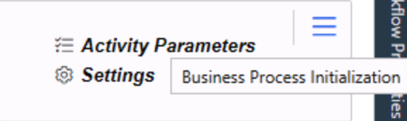

* 1. Click the **Add new parameter** button and click **Add user account Variable**.
  2. Enter **websiteLogin** for the Name, **Website login credentials** for the Description, and **mulesoft** for both the username and password.
  3. Click the **Add new parameter** button and select **Add alphanumeric Variable**.
  4. Enter **rebateCode** for Name, **Rebate code** for Description, and **EV3-WINDOW1** for Variable Value.
  5. Click the **Add new parameter** button and select **Add alphanumeric Variable**.
  6. Enter **rebateVal** for Name, **Rebate amount** for Description, and **$0** for Variable Value.

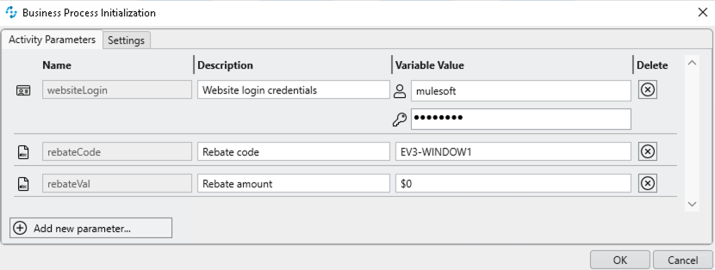

* 1. Click **OK**.

1. Build the Open Rebate Site Bot Task.
   1. Double-click the **Open Rebate Site** Bot Task.
   2. Select all of the activities inside the Transaction, right-click, and select **Disable All Selected**.

**NOTE:** *You could also delete the activities, but we’ll keep them for reference.*

* 1. Select the Toolbox tab and search for **Run Program**. Drag and drop it into the Activity Workflow.
  2. Double-click it to open the Run Program Wizard.
  3. Set the File name to C:\Program Files\Mozilla Firefox\firefox.exe.
  4. In the Parameters, enter -private <https://awesome-car-company.herokuapp.com/>.
  5. Click **Test** and ensure that Firefox opens to the correct website.
  6. Click **OK**.
  7. Click the **Run Workflow** button on the toolbar of this bot task. You should see the Awesome Car Company login page open briefly.
  8. Expand to full screen and click **Save Project** in the upper left.

1. Build the Login Bot Task.
   1. Double-click the **Login** Bot Task.
   2. Select all of the activities inside the Transaction, right-click, and select **Disable All Selected**.
   3. Double-click **Activity Parameters** in the Workflow Initialization block.
   4. Select the **websiteLogin** parameter in the Available Parameters section and move it to the right to the **Used in this Workflow** section.
   5. Click **OK**.
   6. Select the Toolbox tab and search for **AI OCR (screen-based)**.
   7. Drag and drop it into the Activity Workflow. From now on, you add one tool right after another to the Activity Workflow.
   8. Double-click it to open the Wizard.
   9. For the Search mode, select **Text Comparison** and enter **login** for the Search text.
   10. Set the Initial wait time to **3 seconds**.
   11. Click **Test**.
   12. Click **Close**.
   13. Click **Define scan area**.
   14. Outline the image and login link and then click **Accept selection & continue**.

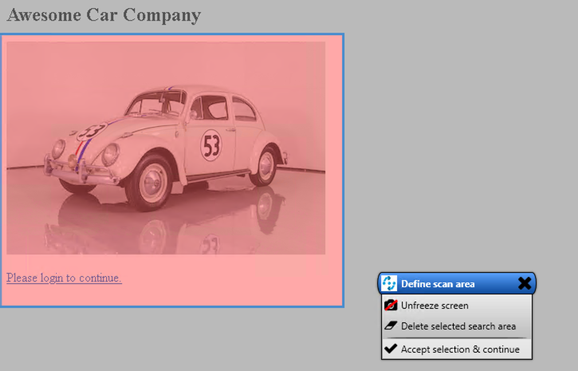

* 1. Click **OK**.
  2. In Firefox, navigate to https://awesome-car-company.herokuapp.com.
  3. In RPA Builder, select the Toolbox tab, search for **Mouse Action**, and then drag and drop it into the Activity Workflow.
  4. Double-click it to open the Wizard.
  5. Name the action **Click Login** and then click the **Start** button.
  6. When Firefox activates, click the **login** link and then press **F10** to exit the capture.
  7. Click **OK**.
  8. Select the Toolbox tab, search for **Keystrokes**, and drag and drop it into the Activity Workflow.
  9. Double-click it to open the Wizard.
  10. Name the action **Refresh** and then click the **Start** button.
  11. When Firefox activates, press **Ctrl+r** and then **F10** to exit the capture.

**NOTE:** *Sometimes the click events from previous actions can interfere with the location of the cursor; therefore, you should refresh the browser to ensure that the tab action works properly.*

* 1. Click **OK**.
  2. Select the Toolbox tab, search for **Keystrokes**, and drag and drop it into the Activity Workflow.
  3. Double-click it to open the Wizard.
  4. Name the action **Tab to Username**, and then click the **Start** button.
  5. When Firefox activates, refresh the page, press the **tab** key, and then press **F10** to exit the capture.
  6. Click **OK**.
  7. Select the Toolbox tab and drag and drop **User Account Decrypter** into the Activity Workflow.
  8. Double-click it to open the Wizard.
  9. In the User account dropdown menu, select **websiteLogin** from Activity Parameters
  10. Click **OK**.
  11. Select the Toolbox tab and drag and drop **Enter String** into the Activity Workflow.
  12. Double-click it to open the Wizard.
  13. Name the action **Enter Username**.
  14. Click the **push pin icon** in the Input String Settings and select **Username** from the User Account Decrypter.
  15. Click **OK**.
  16. Select the Toolbox tab and drag and drop **Keystrokes** into the Activity Workflow.
  17. Double-click it to open the Wizard.
  18. Name the action **Tab to Password** and then click the **Start** button.
  19. When Firefox activates, click the **Username** input field, press the **tab** key, and then press **F10** to exit the capture.
  20. Click **OK**.
  21. Select the Toolbox tab and drag and drop **Enter String** into the Activity Workflow.
  22. Double-click it to open the Wizard.
  23. Name the action **Enter Password**.
  24. Click the **push pin icon** in the Input String Settings and select **Password** from the User Account Decrypter.
  25. Click **OK**.
  26. Select the Toolbox tab and drag and drop **Keystrokes** into the Activity Workflow.
  27. Double-click it to open the Wizard.
  28. Name the action **Login**.
  29. Click the **Add keystroke** plus icon.
  30. Enter {ENTER} for the keystroke and click **OK**.

**NOTE:** *This is an alternative method to clicking the Start button and recording keystrokes.*

* 1. Click **OK**. Your Activity Workflow should look like this.

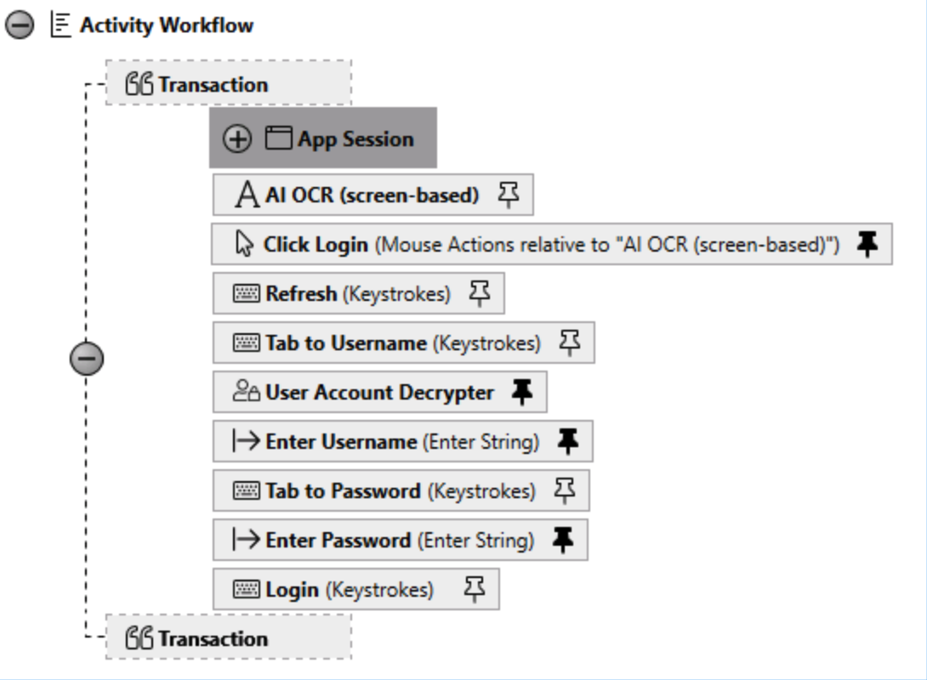

* 1. Click the **Run Workflow** button on the toolbar of this bot task. You should be successfully logged in to the Awesome Car Company site.

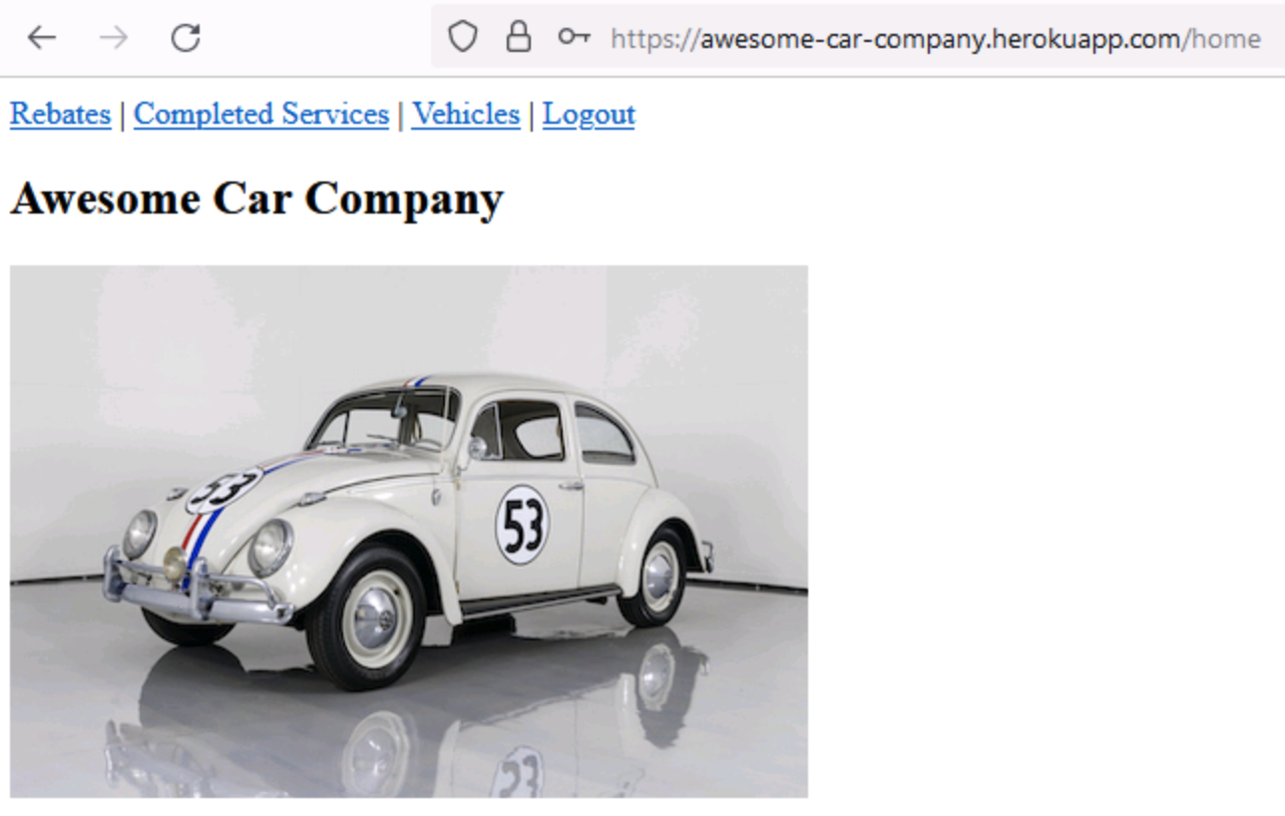

1. Build the Navigate to Rebate Page Bot Task.
   1. Double-click the **Navigate to Rebate Page** Bot Task.
   2. Select all of the activities inside the Transaction, right-click, and select **Disable All Selected**.
   3. Select the Toolbox tab and drag and drop the **AI OCR** tool into the Activity Workflow.
   4. Double-click it to open the Wizard.
   5. For the Search mode, select **Text Comparison** and enter **Rebates** for the Search text.
   6. Set the Initial wait time to **3 seconds**.
   7. In Firefox, navigate to https://awesome-car-company.herokuapp.com/login and login successfully.
   8. Click **Test**.
   9. Click **Close**.
   10. Click **Define scan area**.
   11. Outline the image including the Rebates link at the top and click **Accept selection & continue**.

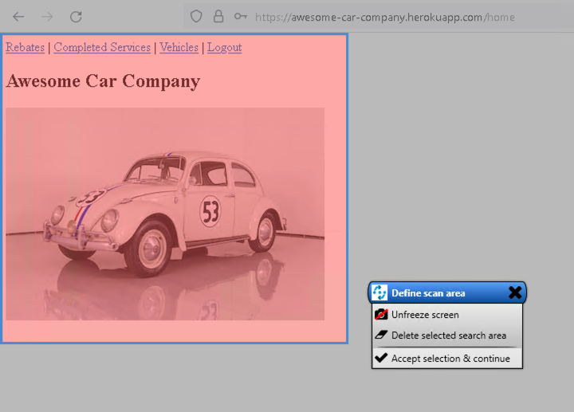

* 1. Click **OK**.
  2. Select the Toolbox tab and drag and drop the **Mouse Action** tool into the Activity Workflow.
  3. Double-click it to open the Wizard.
  4. Name the action **Click Rebates** and then click the **Start** button.
  5. When Firefox activates, click the **Rebates** link and then press **F10** to exit the capture.
  6. Click **OK**.

1. Build the Locate Rebate Bot Task.
   1. Double-click the **Locate Rebate** Bot Task.
   2. Select all of the activities inside the Transaction, right-click, and select **Disable All Selected**.
   3. Double-click **Activity Parameters** in the Workflow Initialization block.
   4. Select both the **rebateCode** and **rebateVal** parameters and move them to the right to the **Used in the Workflow** section.
   5. Click **OK**.
   6. Select the Toolbox tab and drag and drop the **Keystrokes** tool into the Activity Workflow.
   7. Double-click it to open the Wizard.
   8. Name the action **Select all text** and then click the **Start** button.

**NOTE:** *Ensure you are on the Rebates page.*

* 1. When Firefox activates, press **Ctrl+a** and then **Ctrl+c** to select all text and copy it to the clipboard, and then press **F10** to exit the capture.
  2. Click **OK**.
  3. Select the Toolbox tab and drag and drop the **Read Clipboard** tool into the Activity Workflow.
  4. Double-click it to open the Wizard.
  5. Name the action **Extract text** and then click **OK**.
  6. Select the Toolbox tab and drag and drop the **Combine Strings** tool into the Activity Workflow.
  7. Click the **push pin icon** and select the **rebateCode** activity parameter for the first position.
  8. Click **OK**.
  9. Double-click the Combine Strings tool to open the Wizard.
  10. Name the action **Build Regex**.
  11. Click the **{1}: Activity Parameters.rebateCode** link to insert the identifier in the Pattern field.
  12. Enter {1}.*\$[0-9]* in the Pattern field.

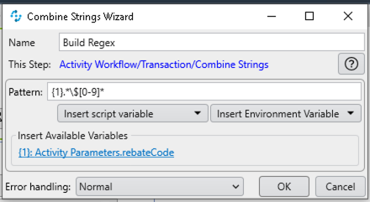

* 1. Click **OK**.
  2. Select the Toolbox tab and drag and drop the **Check Regex** tool into the Activity Workflow.
  3. Double-click the Check Regex tool to open the Wizard.
  4. Name the action **Find rebate**.
  5. For the Regex, select **Build Regex.Combined String**.
  6. For Text Pattern, select **Extract text.ClipboardContent**.
  7. Click **OK**.
  8. Select the Toolbox tab and drag and drop the **Check Regex** tool into the Activity Workflow.
  9. Double-click the Check Regex tool to open the Wizard.
  10. Name the action **Find rebate value**.
  11. For the Regex, enter \$[0-9]*.
  12. For the Text Pattern, click the push pin icon and select **Find rebate.First Match**.
  13. Click **OK**.
  14. Select the Toolbox tab and drag and drop the **Set Variable** tool into the Activity Workflow.
  15. Click the **push pin icon**.
  16. Select the **rebateVal** activity parameter for Variable.
  17. Select the **Find rebate value.First Match** for the New value.
  18. Click **OK**.
  19. Select the Toolbox tab and drag and drop the **Write Clipboard** tool into the Activity Workflow.
  20. Click the **push pin icon**.
  21. Select the **rebateVal** activity parameter for the Clipboard text.

**NOTE:** After *the flow finishes, you will be able to paste the clipboard content into Notepad and view the rebateVal.*

* 1. Click **OK**.
  2. Select the Toolbox tab and drag and drop the **Keystrokes** tool into the Activity Workflow.
  3. Double-click it to open the Wizard.
  4. Name the action **Close Firefox**.
  5. Click the **Add Keystroke** button and add keystrokes for {ALTDOWN}, {F4}, and {ALTUP}.

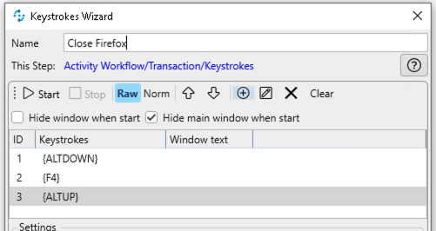

* 1. Click **OK**.

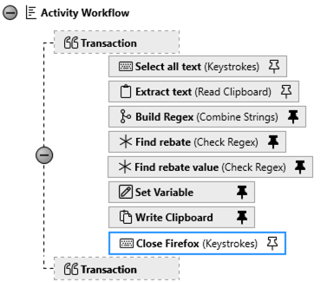

* 1. Click **Save Project** in the upper left.

1. Upload the project to RPA Manager.
   1. Click the Upload Project iconto upload the project to RPA Manager.
   2. Enter some comments regarding your changes, and then click **Upload**.
   3. Return to the project in RPA Manager and refresh the screen; you should see the errors are gone.
   4. Scroll down to the Changelog section to view your upload comments.

# Exercise 3-4: Install and set up an RPA Bot

**Scenario:**

With the RPA process build complete, it’s now time to test the process. EVs R Us wants to install and configure a new bot for its RPA processes.

**Goal:**

Install and configure a new bot to run the RPA process.

**Tasks:**

1. Create new API keys for bots.
2. Install and configure bots.
3. Enable support for secure connections.

**Time:**

30 minutes

**Instructions:**

1. Create an API key.
   1. Select **Bot Management** > **API Key**.
   2. Click **Create**.
   3. In the Create Bot API Key window, enter a name and description and click **OK**.
   4. Copy the newly created API key.
2. Download and install an RPA bot.
   1. Log in to your virtual machine and RPA Manager.
   2. Download the latest RPA bot installer from the home page of RPA Manager.
   3. Right-click the setup file and select **Run as administrator** to start the installation.
   4. For the RPA Manager connection protocol, select **use https as protocol**.
   5. Click **Next**.
   6. For the RPA Manager connection, use the same URL you use to access RPA Manager.
   7. Click **Next**.
   8. Paste the newly created **API Key** in APIKey for the bot.
   9. Continue the installation process until finished and restart the system.
3. Enable support for secure connections.

**NOTE:** *Enable the bot to use Secure Sessions by entering credentials the bot uses to log in to the computer and to open a hidden session. Otherwise, the bot can only use a running desktop session.*

* 1. Double-click the **RPA Bot Configuration** application on the VM’s desktop.
  2. Click  **Secure Session**.
  3. In the **Default Secure Session User** and **Password** input fields, enter the login credentials for the VM.
  4. Uncheck **Use alternative RDP handling for secure session login**.
  5. Click **Test Settings**.
  6. Click **Test** in the new modal to start the session test.
  7. Once the secure session is logged in successfully, click **Logout** and then **Cancel** in the modal.
  8. Click **OK**.
  9. Close the application.

# Exercise 3-5: Test and publish an RPA process

**Scenario:**

EVs R Us has its RPA process built and its bot set up. For the last step, the company would like to successfully test the process before deploying it to production.

**Goal:**

Create a test plan to confirm the proper deployment and execution of the RPA process and then deploy it to production.

**Tasks:**

1. Create simple tests to confirm the proper deployment and execution of processes.
2. Run test plans and monitor the results.
3. Deploy processes to production.

**Time:**

30 minutes

**Instructions:**

1. Test the RPA process.
   1. Click **Publish (Test)** to move the process to the Test phase.
   2. Select the **confirm** checkbox and click **Release to Test**.
   3. Click **Create new test plan**.
   4. Name the test plan **Happy Path** and click **Next**.
   5. Click **Next** in the Activity Parameter tab**.**
   6. Click **Next** in the User task tab.
   7. Click **Next** in the Execution tab.

**NOTE:** *Typically, you would create multiple configurations to test your process using different activity parameters and to test for the completion of user tasks.*

* 1. Select the bot and click **Finish**.
  2. Click **Start tests** and select the **Happy Path** configuration in the modal.
  3. Click **Execute**.
  4. Scroll down to the Test Results section and click the **Update** button until your running bot is visible and displays the results of the test.

**NOTE:** *If there is a failure, click the failure link and download the log files for examination.*

1. Publish the RPA process.
   1. Click **Publish (Production)**.
   2. Select the **confirm** checkbox and click **Release to Production**.
   3. Click the **Create an invokable run configuration** button.
   4. Name the configuration **Invokable config** and then click **Next**.
   5. In the Example column for the activity parameters, enter the same values from the Value column for the rabateCode and rebateVal.
   6. Click **Next**.
   7. Click **Next**.
   8. Select the bot and click **Save & Publish**.

# Exercise 4-1: Create and configure platform access

**Scenario:**

EVs R Us has rigorous security processes in place. The company wants to securely connect Salesforce and Anypoint Platform to protect its data and processes.

**Goal:**

Create and configure services in both Salesforce and Anypoint Platform that will enable secure communication between both platforms.

**Tasks:**

1. Create an authentication provider, which allows your Salesforce org to access MuleSoft Anypoint Platform data.
2. Create a connected app in MuleSoft Anypoint Platform that allows Salesforce to call MuleSoft Anypoint Platform APIs.
3. Set up and authenticate a named credential specifying an endpoint including authentication parameters.

**Time:**

30 minutes

**Instructions:**

1. Create an authentication provider to access MuleSoft Anypoint Platform.
   1. Log in to Salesforce.
   2. Click  **Setup**.
   3. Type **Auth** in the Quick Find search field and select **Auth. Providers**.
   4. Click **New**.
   5. For Provider Type, select **Open ID Connect**.
   6. Enter **MuleSoft Anypoint Platform** for **Name**.
   7. For **Consumer Key** and **Consumer Secret**, enter **TBD**.

**NOTE:** *We’ll update these with the values from MuleSoft Anypoint Platform in the next step.*

* 1. For **Authorize Endpoint URL**, enter https://anypoint.mulesoft.com/accounts/api/v2/oauth2/authorize.
  2. For **Token Endpoint URL**, enter https://anypoint.mulesoft.com/accounts/api/v2/oauth2/token.

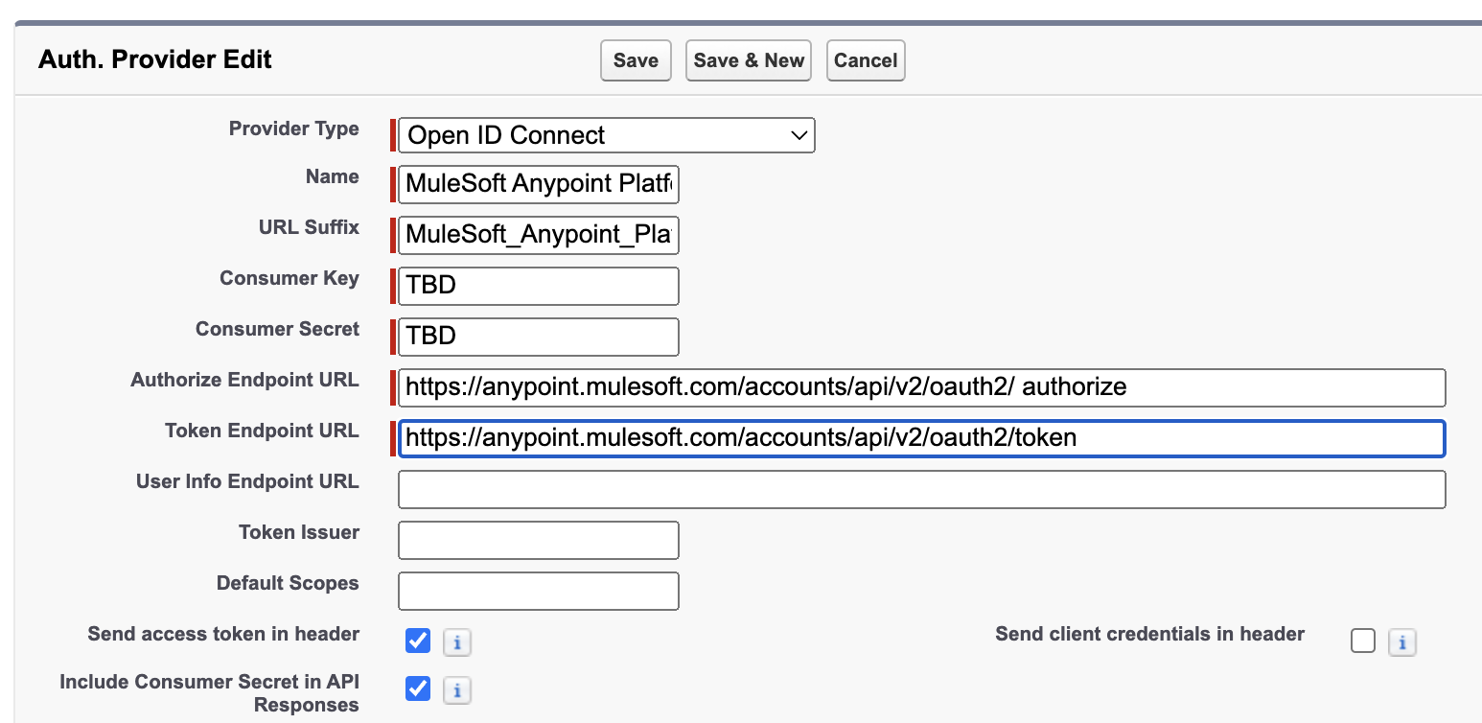

* 1. Click **Save**.
  2. On the Auth. Provider Detail page, in the Salesforce Configuration section, copy the **Callback URL**.

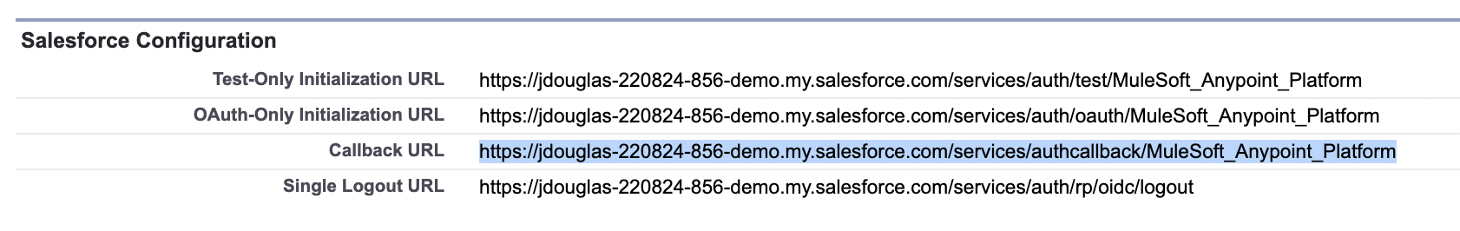

1. Create a connected app in MuleSoft Anypoint Platform.
   1. Log in to Anypoint Platform.
   2. In the main menu, select **Management Center** > **Access Management** > **Connected Apps**.
   3. Click **Create app**.
   4. Enter **Salesforce** for **Name**.
   5. Ensure that **App acts on behalf of a user** is selected for Type.
   6. From Grant types, select **Authorization Code** and **Refresh Token**.
   7. In Website URL, enter **https://www.salesforce.com**.
   8. In **Redirect URIs**, enter the **Callback URL** from the Salesforce Auth. Provider and then click **Add**.
   9. For **Who can use this application?**, select **Members of this organization only**.
   10. Click **Add Scopes**.
   11. Enable **Background Access** and **Read-Only Access**, and then click **Add scopes**.
   12. Click **Save**.

**NOTICE:** The *Copy Id and Copy Secrets buttons on the right for the Salesforce Connected App will be used in the next step.*

1. Update Auth. Provider with client credentials.
   1. Return to the Salesforce Auth. Provider and edit the **MuleSoft Anypoint Platform** provider.
   2. Click the **Copy Id** button for the Salesforce Connected App in Anypoint Platform and paste the ID into the **Consumer Key** text field.
   3. Click the **Copy Secret** button for the Salesforce Connected App in Anypoint Platform and paste the Secret into the **Consumer Secret** text field.
   4. Click **Save**.
2. Authenticate the Anypoint Platform named credential.
   1. Type **Named** in the Quick Find search field and select **Named Credentials**.
   2. Edit the **Anypoint Platform** named credential.
   3. For the authentication provider, click the lookup icon and select your **MuleSoft Anypoint Platform** provider.
   4. Ensure **Start Authentication Flow on Save** is **checked**.
   5. Click **Save**.
   6. Log in with your credentials, if not logged in already, and click **Grant access**.
   7. **Authentication Status** for the named credential should now display **Authenticated**.
3. Modify the Awesome Car Company API named credential.
   1. Type **Named** in the Quick Find search field and select **Named Credentials**.
   2. Click **Edit** for the **Awesome Car Company API** credential.
   3. Modify the URL and enter your Proxy URL. https://awesome-car-company-proxy- {lastname}.{region}.cloudhub.io
   4. Enter **mulesoft** for the **password**.
   5. Click **Save**.

# Exercise 4-2: Create an External Service

**Scenario:**

EVs R Us wants to call the Awesome Car Company’s API from Salesforce Flow. Configure an external service to register the API’s functionality and create invocable actions that can be called from various automations.

**Goal:**

Create an external service to describe an external API’s functionality and register corresponding invocable actions.

**Tasks:**

1. Create external services to describe an external API’s functionality.
2. Register invocable actions from an OpenAPI-compliant specification defining the web service.

**Time:**

10 minutes

**Instructions:**

1. Click  **Setup.**
2. Type **External** in the Quick Find search field and select **External Services**.
3. Click **New External Service**.
4. Select **From MuleSoft Anypoint Platform**.
5. Click **Next**.
6. Select the **Anypoint Platform** named credential.
7. Click **Next**.
8. Select the radio button next to the most recent version of the Awesome Car Company API.
9. Type the recommended **Name** for the External Service, including the version number.

**NOTE:** *Salesforce will generate a number of Apex classes for you with this name. Having the version as part of the name will make it easier to distinguish multiple versions of your API if/when you need to update it.*

1. For **Named Credential**, select **Awesome Car Company API** from the dropdown menu.

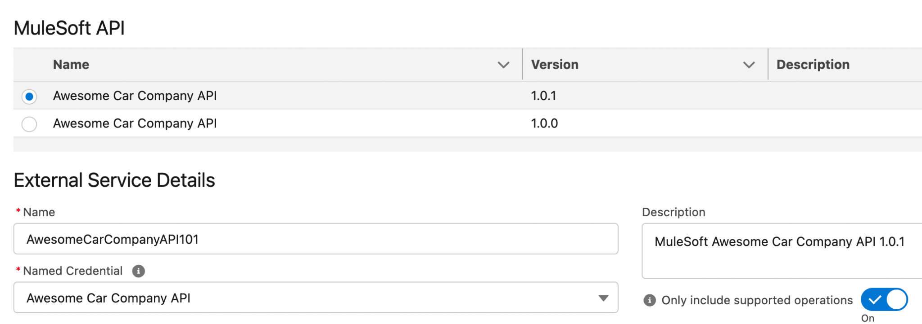

1. Click **Save & Next**.
2. Select **all** of the operations.
3. Click **Next**.
4. Review the actions that were created and then click **Done**.

# Exercise 4-3: Configure MuleSoft Composer

**Scenario:**

EVs R Us wants to use MuleSoft Composer to declaratively create integrations to securely integrate systems and unify data.

**Goal:**

Configure MuleSoft services for MuleSoft Composer.

**Tasks:**

1. Install and connect to MuleSoft Composer with Anypoint Platform.
2. Assign users to a permission set.

**Time:**

10 minutes

**Instructions:**

1. Click  **Setup.**
2. Type **MuleSoft** in the Quick Find search field and select **MuleSoft Composer**.
3. In the Configure MuleSoft Services section, click **Initiate Configuration**.

**NOTE:** *MuleSoft creates and configures an instance of Anypoint Platform to provide a dedicated environment for MuleSoft Composer.*

1. Click the toggle to enable MuleSoft Composer to send email notifications to end users when their flows fail to run.
2. Assign users to the permission set.
   1. Click **Assign Users**.
   2. Click the **Composer User** permission set.
   3. Click **Manage Assignments** and ensure that your user is currently assigned to the permission set.

# Exercise 5-1: Create the EV Case Parts flow

**Scenario:**

EVs R Us wants to automate the process of adding the parts needed to perform a promotional service to the case. Luckily the Awesome Car Company API has an endpoint that provides this data.

**Goal:**

Build a flow that uses an External Service to call the Awesome Car Company API and return parts that are needed for a particular promotion. The parts are inserted as related records to the Case object.

**Tasks:**

1. Use record collections variables to store multiple values.
2. Utilize collection loops for conditional assignment of variables.
3. Use the Create Records action to create multiple records for a collection.

**Time:**

30 minutes

**Instructions:**

1. Create the flow.
   1. Click  **Setup.**
   2. Type **flows** in the Quick Find search field and select **Flows**.
   3. Click **New Flow**.
   4. Select **Autolaunched Flow**.
2. Create the caseId variable for input.
   1. Switch the **Toolbox**  toggle in the upper left.
   2. Click **New Resource**.
   3. Select **Variable** from the dropdown menu.
   4. Enter **caseId** for API Name.
   5. For Data Type, select **Text** from the dropdown menu.
   6. Select **Available for input**.

**NOTE:** *When a variable is available for input, it can be set at the start of the flow, such as when a flow is started from a Lightning page, a process, or another flow.*

* 1. Click **Done**.

1. Create the promotionCode variable for input.
   1. Click **New Resource**.
   2. Select **Variable** from the dropdown menu.
   3. Enter **promotionCode** for API Name.
   4. For Data Type, select **Text** from the dropdown menu.
   5. Select **Available for input**.
   6. Click **Done**.
2. Create the Part variable.
   1. Click **New Resource**.
   2. Select **Variable** from the dropdown menu.
   3. Enter **Part** for API Name.
   4. For Data Type, select **Record** from the dropdown menu.
   5. Search and select **Case Part** in the Object field.
   6. Click **Done**.
3. Create the PartsCollection record variable.
   1. Click **New Resource**.
   2. Select **Variable** from the dropdown menu.
   3. Enter **PartsCollection** for API Name.
   4. For Data Type, select **Record** from the dropdown menu.
   5. Search and select **Case Part** in the Object field.
   6. Select **Allow multiple values (collection)**.
   7. Click **Done**.
4. Create the Get Promotions Parts By Code action.
   1. Click the **Add Element** icon and select **Action**.
   2. In the Action search field, enter and select **getPromotionsPartsByCode**.
   3. Enter **Get Promotions Parts By Code** for Label.
   4. Set the code input value to **{!promotionCode}**.
   5. Expand the **Advanced** section and click **Manually assign variables**.
   6. For 200, click **New Resource**.
   7. Select **Variable** from the dropdown menu.
   8. For API Name, enter **AllParts**.
   9. For Data Type, select **Apex-Defined**.
   10. In the Apex Class search field, enter **ExternalService__AwesomeCarCompanyAPI101_Part**.
   11. Select **Allow multiple values (collection)**.
   12. Click **Done**.
5. Create the Parts loop.
   1. Click the **Add Element** icon after Get Promotions Parts By Code and select **Loop**.
   2. Enter **Parts Loop** for Label.
   3. For Collection Variable, enter **{!AllParts}**.
   4. Click **Done**.
   5. Click the **Add Element** icon after **For Each** and select **Assignment**.
   6. Enter **Part Assignment** for Label.
   7. Set the following values.
      1. **{!Part.Case__c}** equals **{!caseId}**
      2. **{!Part.Name}** equals **{!Parts_Loop.partName}**
      3. **{!Part.Part_Number__c}** equals **{!Parts_Loop.partNumber}**
      4. **{!Part.Price__c}** equals **{!Parts_Loop.price}**
      5. **{!Part.Labor__c}** equals **{!Parts_Loop.labor}**
      6. **{!Part.Total__c}** equals **{!Parts_Loop.total}**
   8. Click **Done**.
6. Create the Add Part to Collection assignment.
   1. Click the **Add Element** icon after **Part Assignment** and select **Assignment**.
   2. Enter **Add Part to Collection** for Label.
   3. For Variable, select **{!PartsCollection}**.
   4. For Operator, select **Add** from the dropdown menu.
   5. For Values, enter **{!Part}**.
   6. Click **Done**.
7. Create the Create Case Parts create records action.
   1. Click the **Add Element** icon after **After Last** and select **Create Records**.
   2. Enter **Create Case Parts** for the Label.
   3. Select **Multiple** for How Many Records to Create.
   4. For Record Collection, select **{!PartsCollection}**.
   5. Click **Done**.
8. Save and debug the flow.
   1. Click **Save** in the upper right to save the flow.
   2. Label the flow **EV Case Parts**.
   3. Click **Save**.
   4. In another Salesforce tab, click the **App Launcher** icon  and then search for the **EVs R Us** app.
   5. Select the **Cases** tab, select the **All Open Cases** list view, and then select **any case**.
   6. Copy the ID portion of the URL.

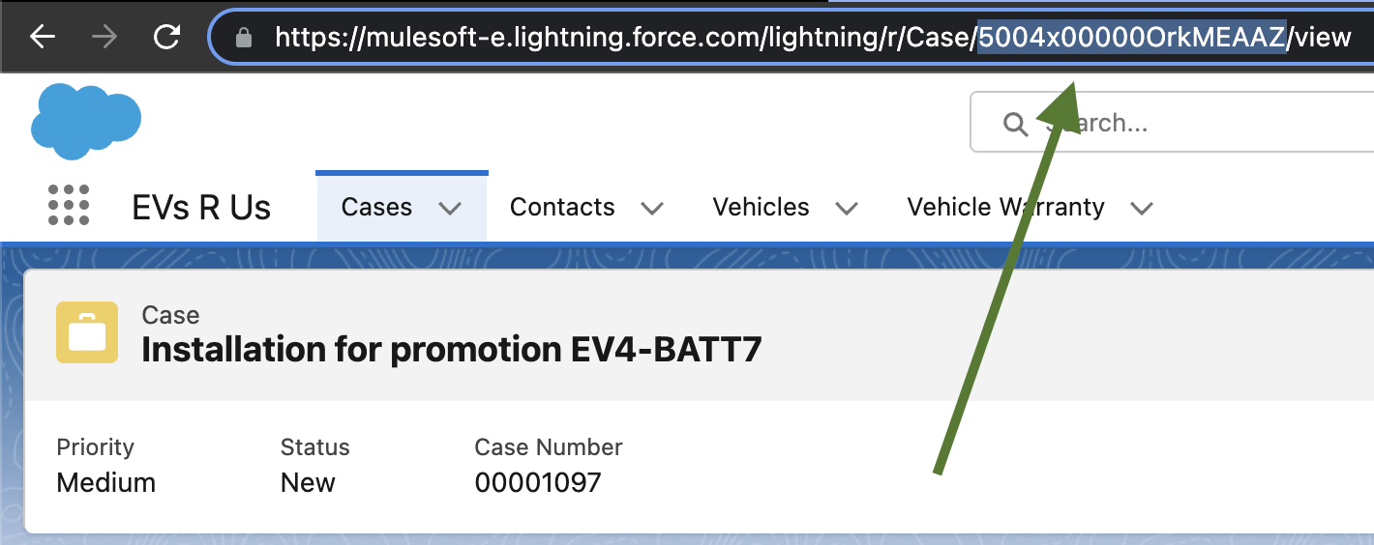

* 1. After the flow has finished saving, click the **Debug** button.
  2. In the **caseId** field, paste the **ID** from the URL.
  3. In the **promotionCode** field, enter **EV4-BATT7**.
  4. Click **Run**.
  5. Click the **Expand All** button and examine the debug logs.
  6. **NOTE:** *The flow should finish successfully and the Create Case Parts at the bottom should contain a single record to be created.*

1. Activate the flow.
   1. Click the **Activate** button.

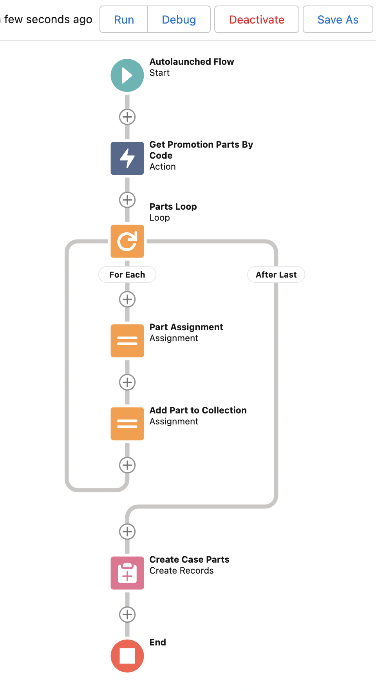

# Exercise 5-2: Modify the EV Vehicle Promotions flow

**Scenario:**

Awesome Car Company has an API that returns promotions for a specific vehicle. EVs R Us wants to automate this retrieval so that it can be used in other automations.

**Goal:** Modify the flow that uses an External Service to call the Awesome Car Company API and return promotions for a specific vehicle.

**Tasks:**

1. Create actions that use External Services and Apex-defined variables.
2. Assign variables at runtime.
3. Filter collections based upon filter conditions.
4. Debug flows.

**Time:**

15 minutes

**Instructions:**

1. Modify the **EV Get Vehicle Promotions** flow.
   1. Click the Flow Builder back button in the upper left.
   2. Click **EV Get Vehicle Promotions**.
2. Create the Get Promotions action.
   1. Click the **Add Element** iconafter the Autolaunched Flow Start and select **Action**.
   2. In the Action search field, enter **getPromotions**.
   3. Enter **Get Promotions** for Label.
   4. Expand the **Advanced** section and click **Manually assign variables**.
   5. For 200, click inside the **Search variables** box and then select **New Resource**.
   6. Select **Variable** from the dropdown menu.
   7. For API Name, enter **AllPromotions**.
   8. For the Data Type, select **Apex-Defined**.
   9. In the Apex Class search field, enter **ExternalService__AwesomeCarCompanyAPI101_Promotion**.
   10. Select **Allow multiple values (collection)**.
   11. Click **Done**.
   12. Click **Done**.
3. Create the Filtered Promotions collection filter.
   1. Click the **Add Element** icon after Assign Vehicle Name and select **Collection Filter**.
   2. Enter **Filtered Promotions** for the Label.
   3. For Collection, use the **AllPromotions** collection.
   4. In the first filter condition, set the **vehicle** field **equal** to **{!Vehicle_Name}**.
   5. Click the **Add Condition** button.
   6. Set the **expired** field **equal** to **{!$GlobalConstant.False}**.
   7. Click **Done**.
4. Create the Assign Promotions assignment.
   1. Click the **Add Element** icon after Filtered Promotions and select **Assignment**.
   2. Enter **Assign Promotions** **for Output** for Label.
   3. For Variable, click **New Resource**.
   4. Select **Variable** from the dropdown menu.
   5. For API Name, enter **PromotionsforOutput**.
   6. For Data Type, select **Apex-Defined**.
   7. In the Apex Class search field, enter **ExternalService__AwesomeCarCompanyAPI101_Promotion**.
   8. Select **Allow multiple values (collection)**.
   9. Select **Available for output**.

**NOTE:** *When a variable is available for output, it can be accessed throughout the flow, such as by a Lightning web component or another flow.*

* 1. Click **Done**.
  2. For Value, select **{!Filtered_Promotions}**.
  3. Click **Done**.

1. Save and debug the flow.
   1. Click **Save As** in the upper right to save the flow.
   2. Click **Save**.
   3. After the flow has finished saving, click the **Debug** button.
   4. In **contactVehicle**, search for and select **V-0001**, and then click **Run**.
   5. Click the **Expand All** button and examine the debug logs; you should see that the Filtered Promotions collection at the bottom contains two records.
2. Activate the flow.
   1. Click the **Activate** button.

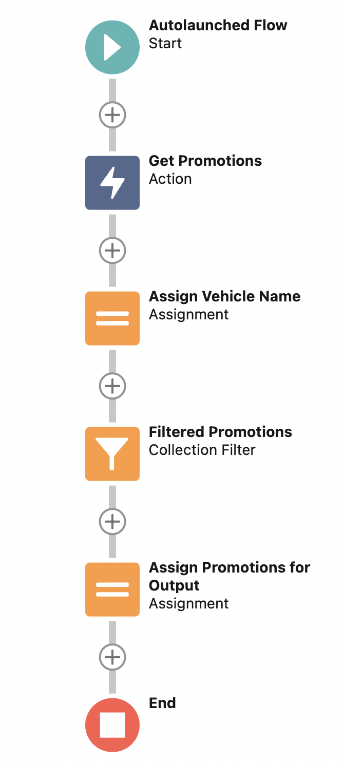

# Exercise 5-3: Modify the EV Create Case flow

**Scenario:**

Creating a case is the first step in the scheduled vehicle service internal process. EVs R Us would like to automate this using Flow.

**Goal:**

Modify an existing flow to use an Apex-defined variable for input.

**Tasks:**

1. Use Apex-defined data types for input variables.
2. Modify elements using merge fields, operators, and functions.

**Time:**

10 minutes

**Instructions:**

1. Modify the EV Create Case flow.
   1. Click the Flow Builder back button in the upper left.
   2. Click **EV Create Case**.
2. Create the promotion variable for input.
   1. Click **New Resource**.
   2. Select **Variable** from the dropdown menu.
   3. Enter **promotion** for API Name.
   4. For Data Type, select **Apex-Defined**.
   5. In the Apex Class search field, enter **ExternalService__AwesomeCarCompanyAPI101_Promotion**.
   6. Select **Available for input**.
   7. Click **Done**.
3. Modify the Description formula.
   1. Switch the **Toolbox**  toggle in the upper left.
   2. Click the **Description** formula.
   3. For Formula, replace the current formula with "Installation for promotion " & {!promotion.code}.
   4. Click **Done**.
4. Modify the Subject formula.
   1. For Formula, replace the current formula with "Installation for " & {!promotion.name} & " . " & {!promotion.vehicle}.
   2. Click **Done**.
5. Modify the Create Case action.
   1. Edit the **Create Records** element.
   2. For the Promotion__c field, change the Value to {!promotion.code}.
   3. Click **Done**.
6. Save and Activate the flow.
   1. Click **Save As** in the upper right to save the flow.
   2. Click **Save**.
   3. After the flow has finished saving, click the **Activate** button.

# Exercise 5-4: Create the Promotional Rebates MuleSoft Composer flow

**Scenario:**

Awesome Car Company provides rebates for some of its promotions. This frequently changing amount is available from its restricted internal dealer site. EVs R Us has built an RPA automation to return this amount and wants it to be called whenever a new scheduled vehicle service case is created. This rebate amount is updated on the case.

**Goal:**

Build a flow that fires when a case is created and invokes a MuleSoft RPA automation to return the rebate amount for a specific promotion.

**Tasks:**

1. Define Salesforce system events triggered by conditional filters.
2. Configure connections to MuleSoft RPA accounts.
3. Invoke MuleSoft RPA automations.
4. Create custom expressions with data manipulation, functions, and formulas.

**Time:**

45 minutes

**Instructions:**

1. Create the MuleSoft Composer flow.
   1. Click the **App Launcher** icon  and then search for the **MuleSoft Composer** app.
   2. Click the **Composer Flows** tab and then the **New Flow** button.
   3. Click **System Event**.
2. Configure the Salesforce start system event.
   1. For System Event, select **Salesforce**.
   2. Enter **This Org** for Connection Display Name and click **Create**.
   3. Log in to your current Salesforce org (again).
   4. On the Allow Access page, click **Allow**.
   5. From the **Choose an event that starts this flow** dropdown menu, select **New record**.
   6. In the Object Type field, search for and select **Case**.
   7. For the Conditions to filter the objects, select **All conditions must be met (AND)**.
   8. For the first field, search and select **Promotion**.
   9. Select **Is Not Empty** for Operator and leave Value blank.
   10. Click **Add a condition**.
   11. For Field, search and select **Case Type**.
   12. Select **Equals** for Operator and enter **Scheduled Service** for Value.
   13. Click **Add a condition**.
   14. For Field, search and select **Covered by Service Contract**.
   15. Select **Equals** for Operator and enter **false** for Value.
3. Configure the MuleSoft RPA action.
   1. Click the **Next Step** icon at the bottom.
   2. Select **System Action** and then **MuleSoft RPA**.
   3. For Connection Display Name, enter **My RPA Account**.
   4. Enter your **RPA API URL** per the instructions below the field.
   5. Locate your **API Key** in MuleSoft RPA and enter it in the **User API Key** field.
   6. Click **Connect**.
   7. Select **Invoke RPA Process** for Action.
   8. Select your process of the **Awesome Car Company Rebate Lookup** for RPA Process in the dropdown menu.
   9. The RPA automation runs fast enough to be used in the current flow, so select **Use response in this flow** for Output.
   10. Click **Select Additional** **Fields**.
   11. Select **RebateCode** and click **Apply**.
   12. For RebateCode, search for and select **Promotion**.
4. Configure the Salesforce update action.
   1. Click the **Next Step** icon.
   2. Select **System Action** and then **Salesforce**.
   3. Select **This Org** for the Salesforce connection.
   4. Select **Update Record** from the Action dropdown menu.
   5. Search and select **Case** for Object Type.
   6. Enter **Case ID** in the Case ID field.
   7. Click the **Select Additional Fields** button.
   8. Select the **Rebate Amount** field and click **Apply**.
   9. Click the **Rebate Amount** field and select **Custom Expression**.

**NOTE:** *The Rebate Amount field holds numeric values, but the RPA automation returns rebateVal as a string with a dollar sign (e.g., $500); therefore, we have to remove the dollar sign and convert the string to a number using a custom expression.*

* 1. In the **Search functions** search field, enter **fromString** and then select **fromStringToNumber**.
  2. In the **Search functions** search field, enter **sub** and select **substitute**.
  3. Click the **Data** tab.
  4. Enter **rebate** in the **Search data** search field and select **Rebate Val** from the results.
  5. Enter **$** for the second position in the function.
  6. Enter **0** for the third position in the function.

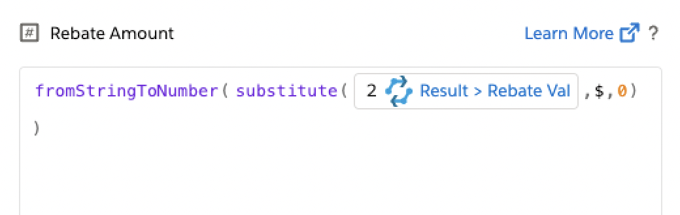

**NOTE:** *Ensure that there is a checkmark next to Valid syntax at the bottom.*

* 1. Click **Apply**.

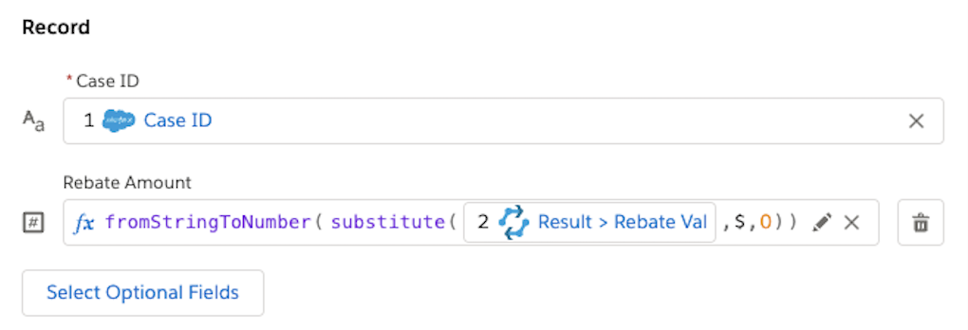

* 1. Click **Save**, name the flow **Promotional Rebates**, and click **Apply**.

1. Test the flow.
   1. Click **Test** and wait for the service to start and display Awaiting trigger event.
   2. Click  and select **Developer Console**.
   3. Select the **Debug** menu and then select **Open Execute Anonymous Window**.
   4. Paste the following Apex code snippet and click the **Execute** button.

EVApp.testRebatesComposerFlow();

**NOTE:** *This custom Apex method will insert the Case data needed for the flow to execute successfully.*

* 1. In another Salesforce tab, click the **App Launcher** icon  and then search for the **EVs R Us** app.
  2. Select the **Cases** tab and then select the **Recently Viewed** list (if not already selected).
  3. Click the **Rebates Composer Flow Test** case.

**NOTICE:** *Rebate Amount is currently $0.*

* 1. Return to the **Promotional Rebates** flow where the test is currently in progress and wait for the test to complete successfully.
  2. Return to the **Rebates Composer Flow Test** case, refresh the page, and confirm that **Rebate Amount** has been updated.
  3. Return to the **Promotional Rebates** flow and click **Activate**.

# Exercise 5-5: Create the Service Case Closed MuleSoft Composer flow

**Scenario:**

When a scheduled vehicle service case is completed, EVs R Us would like to add the case info to a Google Sheet for the marketing department, notify the accounting department via Slack, and make a POST to the Awesome Car Company’s API.

**Goal:**

Build a flow that fires when a case is closed and also adds a new row to a Google Sheet, posts a message to Slack, and performs an HTTP POST to the Awesome Car Company API.

**Tasks:**

1. Use the Google Sheets Connector to create rows in a spreadsheet.
2. Use the Slack Connector to post messages to channels.
3. Create HTTP connections using Basic Authentication.
4. Provide sample request and response JSON.
5. Use the HTTP Connector to make a POST request.

**Time:**

60 minutes

**Instructions:**

1. Create the MuleSoft Composer flow.
   1. Click the **Composer Flows** tab and then the **New Flow** button.
   2. Click **System Event**.
2. Configure the Salesforce start system event.
   1. For the system event to start the flow, select **Salesforce**.
   2. Select **This Org** for the Salesforce connection.
   3. From the **Choose an event that starts this flow** dropdown menu, select **New or updated record**.
   4. Search and select **Case** for Object Type.
   5. For the **Conditions** to filter the objects, select **All conditions must be met (AND)**.
   6. For the first condition, set **Status** equals **Closed**.
   7. Click **Add a condition**.
   8. For the second condition, set **Case Type** equals **Scheduled Service**.
3. Configure the Google Sheets create row action.  
   **NOTE:** *If you haven’t done so already, create a Google Sheet with the following columns: Case, Name, Phone, Email, Appointment Date, Completion Date, and Service Performed.*
   1. Click the **Next Step** icon at the bottom and select **System Action**.
   2. Select **Google Sheets** as the next system action.
   3. Enter **My Google Account** for Connection Display Name and click **Connect**.
   4. Click **Sign in with Google** in the modal.
   5. Log in to your Google account that has your **EVs R Us Service Followup** spreadsheet.
   6. Follow the prompts to grant access to your account.
   7. For **Action**, select **Create row** from the dropdown menu.
   8. For **Spreadsheet ID**, locate and select your **EVs R Us Service Followup** spreadsheet.
   9. Select your worksheet for **Worksheet name**.
   10. Click **Select Columns**.
   11. Click **Select all 7 fields** at the bottom and click **Apply**.
   12. Enter the following Columns.
       1. **Appointment Date** > **Appointment**
       2. **Case** > **Case Number**
       3. **Completion Date** > **Closed Date**
       4. **Email** > **Contact Email**
       5. **Name** > **Contact Name**
       6. **Phone** > **Contact Phone**
       7. **Service Performed** > **Subject**
4. Configure the Slack post message action.  
   **NOTE:** *If you haven’t done so already, in a new or existing Slack workspace, create a new* ***#accounting*** *channel.*
   1. Click the **Next Step** icon at the bottom and select **System Action**.
   2. Select **Slack** as the next system action.
   3. Enter **Accounting Workspace** for **Connection Display Name** and click **Connect**.
   4. Log in to your **Accounting Workspace** workspace and click **Allow**.
   5. For **Action**, select **Post message to channel** from the dropdown menu.
   6. For Channel Name, select **accounting** from the dropdown.
   7. For Message, select **Custom Expression**.
   8. In the right side of the expression editor, enter **Please bill Awesome Car Company for Case**.
   9. Click the **Data** tab.
   10. Enter **Case** in the Search data search field and select **Case Number** from the results.
   11. Ensure that there is a checkmark next to **Valid syntax** at the bottom.
   12. Click **Apply**.

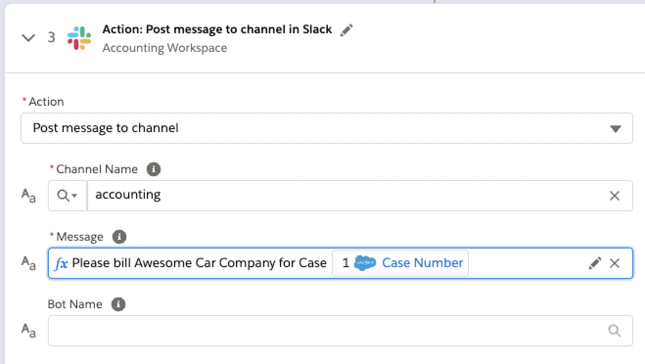

1. Configure the HTTP post action.
   1. Click the **Next Step** icon and select **System Action**.
   2. Select **Use the** **HTTP Connector** as the next system action.
   3. Enter **Awesome Car Company API** for Connection Display Name.
   4. Select **Basic Authentication** for Authentication Type.
   5. For **Base URL**, enter your Proxy URL. https://awesome-car-company-proxy-{lastname}.{region}.cloudhub.io
   6. Enter **mulesoft** for both Username and Password.
   7. Click **Next**.
   8. Enter /promotions for Request Path.
   9. Click **Connect** and ensure that the connection was created successfully.
   10. For Action, select **Simple Request** from the dropdown menu.
   11. Select **POST** from the dropdown menu of HTTP methods.
   12. For **Path**, select **Custom Expression** from the dropdown menu.
   13. In the right side of the expression editor, enter /vehicles/.
   14. Click the **Data** tab.
   15. Enter **vin** in the Search data search field and select **VIN** from the results.
   16. In the right side of the expression editor, add /service after the VIN.
   17. Ensure that there is a checkmark next to **Valid syntax** at the bottom.

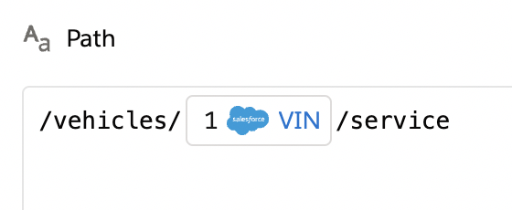

* 1. Click **Apply**.
  2. Click **Add Headers**.
  3. Enter **Content-Type** for the Key and **application/json** for the Value.
  4. Click **Add Example Request** and add the following JSON payload.

{

"vin": "4Y1SL65848Z411439",

"serviceType": "Battery Upgrade",

"promotionCode": "EV4-BATT7",

"serviceDate": "2021-09-14"

}

* 1. Click **Save**.
  2. Click **Select Additional Fields** for Body.
  3. Click **Select all 4 Fields** and then click **Apply**.
  4. Enter the following fields for **Body**.
     1. Promotion Code > Promotion
     2. Service Type > Subject
     3. Vin > VIN
  5. For the **Service Date** field, select **Custom Expression** from the dropdown menu.
  6. In the Search functions search field, enter **fromDateTime** and select **fromDateTimeToString**.

**NOTE:** *Read the documentation of the function.*

* 1. Change the format of the date in the second parameter to yyyy-MM-dd.
  2. Backspace to the empty datetime input value section in the first parameter.
  3. Click the **Data** tab.
  4. Enter **Closed Date** in the Search data search field and select **Closed Date** from the results.

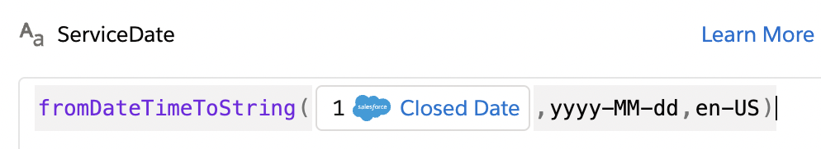

* 1. Ensure that there is a checkmark next to **Valid syntax** at the bottom.
  2. Click **Apply**.
  3. Click **Add Example Response** and add the following JSON payload.

{

"id": "62925d82-487a-4249-ae32-aaf960c476c5",

"vin": "4Y1SL65848Z411439",

"serviceType": "Battery Upgrade",

"promotionCode": "EV4-BATT7",

"serviceDate": "2021-09-11T00:00:00",

"createdDate": "2022-09-11T12:53:43.335843"

}

* 1. Click **Save**.
  2. Save the flow.
  3. Enter **Service Case Closed** for the name and click **Apply**.

1. Test the flow.
   1. Click **Test** and wait for the service to start and display Awaiting trigger event.
   2. Navigate to <https://awesome-car-company.herokuapp.com/services/completed> and note the number of completed service records.
   3. Click  and select **Developer Console**.
   4. Select the **Debug** menu and select **Open Execute Anonymous Window**.
   5. Paste the following Apex code snippet and click the **Execute** button.

EVApp.testServiceCaseClosedComposerFlow();

* 1. Wait for the test to complete successfully.
  2. Ensure that you see a new row in your spreadsheet, a new message in your Slack #accounting channel, and a new record for the completed services on the Awesome Car Company’s website.
  3. Click **Activate**.

# Exercise 5-6: Create the EV Scheduled Service Orchestration

**Scenario:**

Performing a scheduled vehicle service is a complex process that requires numerous departments to operate in concert over an extended period of time. EVs R Us would like to streamline and automate this process using Flow Orchestration.

**Goal:**

Build an Orchestration to automate the multi-user, multi-step process to approve, schedule, and prepare the scheduled vehicle service case.

**Tasks:**

1. Configure conditional start elements.
2. Route flows based upon runtime decisions.
3. Define stages to group related steps, organizing them into logical phases.
4. Create interactive steps that require user interaction.
5. Create background steps that run autolaunched flows.

**Time:**

60 minutes

**Instructions:**

1. Create the Flow Orchestration.
   1. Click  **Setup**, type **flows** in the Quick Find search field, and select **Flows**.
   2. Click **New Flow**.
   3. Click **All + Templates**.
   4. Select **Flow Orchestration** from the left menu.
   5. Select **Record-Triggered Orchestration**.
   6. Click **Create**.
2. Configure the start element.
   1. Click the **Edit** link next to Account Object in the start element.
   2. Change Object to **Case**.

**NOTE:** *Ensure that Trigger the Orchestration When is set to* ***A record is created****.*

* 1. For Condition Requirements, select **All Conditions Are Met (AND)** from the dropdown menu.
  2. For Fields, add the following three conditions.
     1. Status equals New.
     2. Type equals Scheduled Service.
     3. Origin equals Chat.
  3. Click **Save**.
  4. Name the Orchestration **EV Scheduled Service** and click **Save**.
  5. Click the **x** in the upper right to close the view.

1. Create the Service Contract Decision decision.
   1. Click the **Add Element** icon after the start element and select **Decision**.
   2. Enter **Service Contract Decision** for Label.
   3. For the selected New Outcome tab, enter **Has Service Contract** for Label.
   4. For Resource, enter **{!$Record.Has_Service_Contract__c}** equals **True**.
   5. Click the **Default Outcome** tab and change the Label to **No Service Contract**.
   6. Click close.

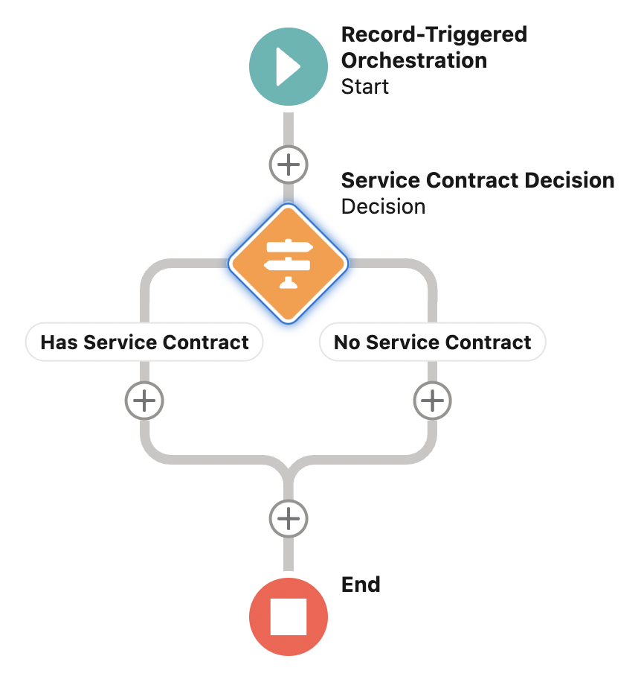

* 1. Click the **Add Element** icon after the **No Service Contract** decision element and select **Stage**.
  2. Set both the Label and API Name to **Approval**.
  3. Click close.

1. Create the Approved by AR Dept interactive step.
   1. Click **Add Step** in the Approval step and select **Interactive Step**.
   2. Set Label to **Approved by AR Dept** and API Name to **Approved_by_AR_Dept**.
   3. In the Flow search field, find and select the **EV Accounts Receivable Approval** flow.
   4. After the flow loads, enter **{!$Record.Id}** for the **caseId** input value.
   5. For **Record ID** in the Specify Record Page section, enter **{!$Record.Id}**.
   6. For Assignee Type, select **Group** from the dropdown menu.
   7. In the Group search field, find and select **Accounts Receivable Dept**.
   8. Click the **Add Element** icon after the Approved by AR Dept element and select **Decision**.
   9. Enter **AR Dept Approval** for Label.
   10. For the selected New Outcome tab, enter **Approved** for Label.
   11. For Resource, enter **{!Approved_by_AR_Dept.Outputs.Approved_Status}** equals **True**.
   12. Click the Default Outcome tab and change the label to **Not Approved**.
   13. Click close.

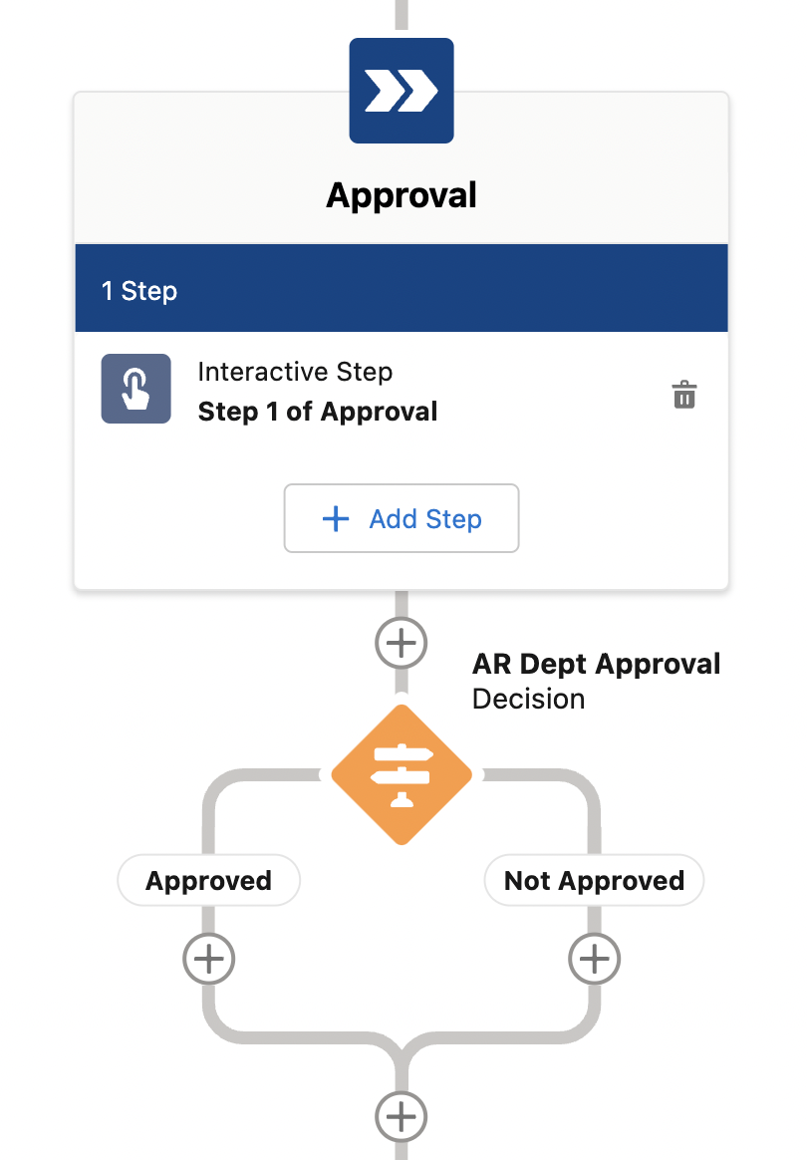

1. Create the AR Rejection stage.
   1. Click the **Add Element** icon after the **Not Approved** decision element and select **Stage**.
   2. Set Label to **AR Rejection**.
   3. Click close.
2. Create the Send AR Rejection Email background step.
   1. Click **Add Step** in the AR Rejection step and select **Background Step**.
   2. Set Label to **Send AR Rejection Email**.
   3. In the Flow search field, find and select the **EV Accounting Rejection Email** flow.
   4. After the flow loads, switch the **caseId** toggle from Don’t Include to **Include**.
   5. Enter **{!$Record.Id}** for the **caseId** input value.
   6. Click close.
3. Create the Update Case Status background step.
   1. Click **Add Step** in the AR Rejection step and select **Background Step**.
   2. Set Label to **Update Case Status**.
   3. In the Flow search field, find and select the **EV Update Case Status** flow.
   4. After the flow loads, switch the **caseId** toggle from Don’t Include to **Include**.
   5. Enter **{!$Record.Id}** for the **caseId** input value.
   6. Click close.
4. Create the End element.
   1. Click the **Add Element** icon after the **AR Rejection** stage and select **End**.
5. Create the Parts & Service stage.
   1. Click the **Add Element** icon at the very bottom and select **Stage**.

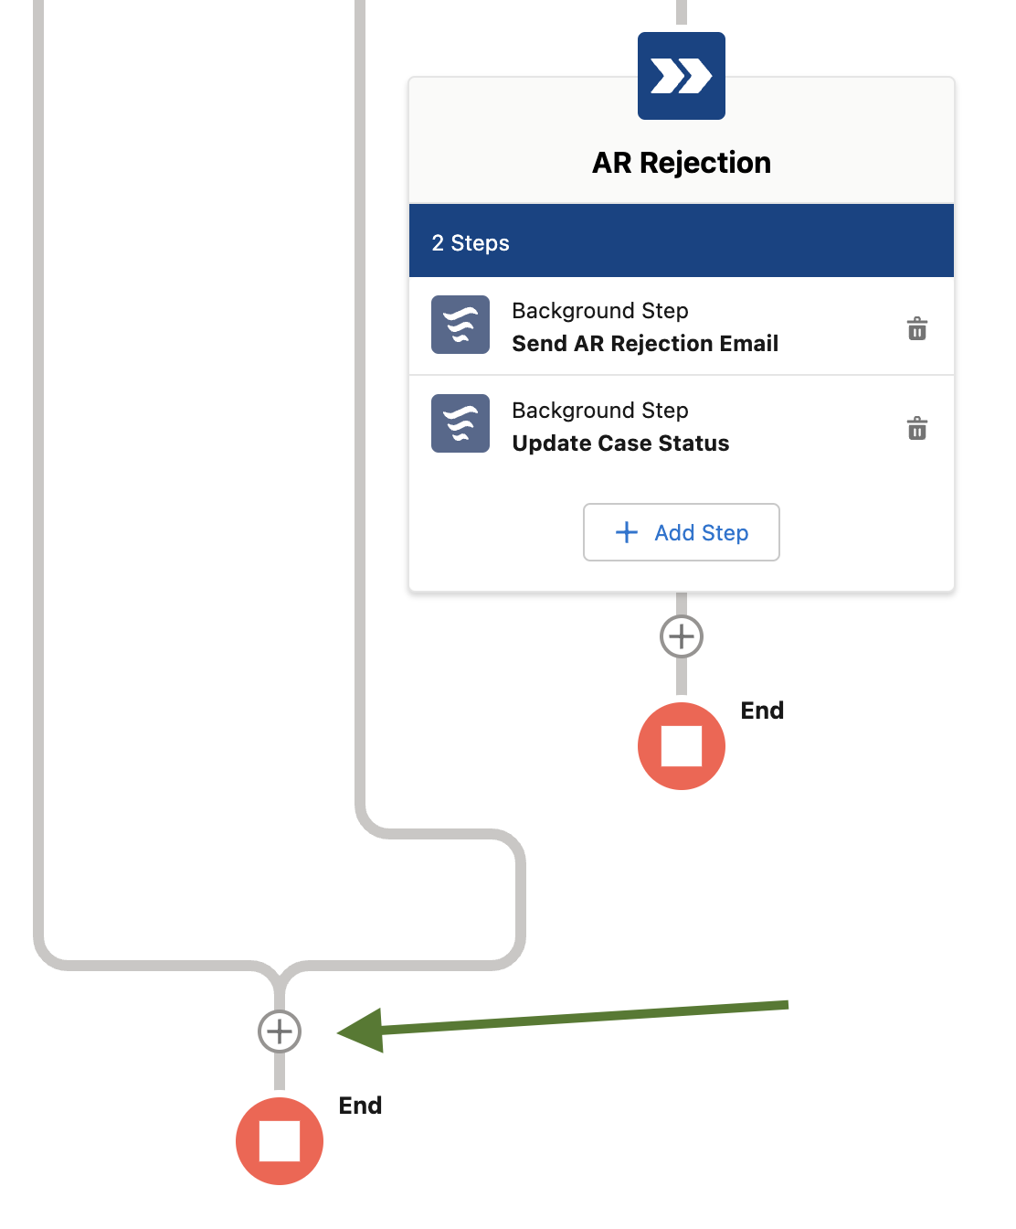

* 1. Set Label to **Parts & Service**.
  2. Click close.

1. Create the Get Parts background step.
   1. Click **Add Step** in the Parts & Service step and select **Background Step**.
   2. Set Label to **Get Parts**.
   3. In the Flow search field, find and select the **EV Case Parts** flow.
   4. Select the **Contains external callouts or pause elements** checkbox.
   5. After the flow loads, switch the toggle from Don’t Include to **Include** for both input values
   6. Enter **{!$Record.Id}** for **caseId** and **{!$Record.Promotion__c}** for **promotionCode**.
   7. Click close.
2. Create the Schedule Appointment interactive step.
   1. Click **Add Step** in the Parts & Service step and select **Interactive Step**.
   2. Set Label to **Schedule Appointment**.
   3. In the Flow search field, find and select the **EV Service Appointment** flow.
   4. After the flow loads, switch the toggle from Don’t Include to **Include**.
   5. Enter **{!$Record}** for the **Case** input value.
   6. For Record ID in the Specify Record Page section, enter **{!$Record.Id}**.
   7. For Assignee Type, select **Group** from the dropdown.
   8. In the Group search field, find and select **Service Dept**.
   9. Click close.
3. Create the Parts Status interactive step.
   1. Click **Add Step** in the Parts & Service step and select **Interactive Step**.
   2. Set Label to **Parts Status**.
   3. In the Flow search field, find and select the **EV Parts Status** flow.
   4. After the flow loads, switch the toggle from Don’t Include to **Include.**
   5. Enter **{!$Record}** for the **Case** input value.
   6. For Record ID in the Specify Record Page section, enter **{!$Record.Id}**.
   7. For Assignee Type, select **Group** from the dropdown menu.
   8. In the Group search field, find and select **Parts Dept**.
   9. Click close.
4. Create the Send Appointment Email background step.
   1. Click **Add Step** in the Parts & Service step and select **Background Step**.
   2. Set Label to **Send Appointment Email**.
   3. For Entry Condition, select **When another step is marked Complete, the step starts**.
   4. From the Step Name dropdown menu, select **Schedule Appointment**.
   5. In the Flow search field, find and select the **EV Appointment Confirmation Email** flow.
   6. After the flow loads, switch the toggle from Don’t Include to **Include** and enter **{!$Record.Id}** for **caseId**.
   7. Click close.
5. Save and activate the orchestration.
   1. Click **Save**.
   2. Click **Activate**.

# Exercise 6-1: Create an Einstein chatbot

**Scenario:**

EVs R Us is expecting a large increase in service requests for Awesome Car Company’s new promotions. It would like to implement an Einstein Bot to automate the process of scheduling service, thus streamlining the process for customers and allowing agents to concentrate on complex issues that require creativity or teamwork.

**Goal:**

Create an Einstein chatbot to make customer service smarter and more efficient.

**Tasks:**

1. Create Einstein chatbots.
2. Configure dialogs, questions, and actions.
3. Use actions to leverage flows.
4. Dynamically build menus from data in Salesforce.

**Time:**

75 minutes

**Instructions:**

1. Enable Einstein Bots.
   1. Click  **Service** **Setup**, type **einstein** in the Quick Find search field, and select **Einstein Bots**.
   2. In the upper right, switch the **Einstein Bots** toggle to **on**.
2. Create an Einstein bot.
   1. Click **Create a New Bot**.
   2. Select **Standard Bot** and click **Next**.
   3. Select the **Start from Scratch** bot type and click **Next**.
   4. Enter **EV the Support Bot** for the bot’s name and click **Next**.
   5. Enter **Respond to Promotional Offer** for Menu Item 1.
   6. Enter **Repair Status** for Menu Item 2.
   7. Click **Next**.
   8. Click **Next** to skip the Embedded Service Deployment.
   9. Click **Proceed**.
   10. Click **Finish**.
3. Link the bot to an existing service.
   1. Click the **Dialogs** dropdown menu in the upper left and select **Overview**.
   2. Click the **Add** button in the Connections section.
   3. Select **Chat** from the Connections dropdown menu.
   4. Enter **EV** in the Deployment search field and select **EV Support Group**.
   5. Click **Save**.
   6. Click the **Overview** dropdown menu in the upper left and select **Dialogs**.
4. Configure the Welcome dialog.
   1. Click the **Welcome** dialog.
   2. Click the **plus sign** between the Message and Next Step dialogs.

**NOTE:** *Hover over the space between the dialogs for the new dialog plus sign to magically appear.*

* 1. Click **Action**.
  2. Drag the new Action and drop it before Message so that it runs first.
  3. Select **Flow** from the Action Type dropdown menu.
  4. For Action Name, select **EV Pre-Chat Context**.
  5. Choose **[Context] Routable Id (Id)** for the Variable Name.

**NOTE:** *When the chat session starts, the EV Pre-Chat Context flow runs and returns a number of variables that are used by the bot.*

* 1. For **Email_Address**, select **New Text Variable** from the dropdown menu, enter **Email** for Name, and click **Save**.
  2. For **First_name**, select **New Text Variable** from the dropdown menu, enter **First Name** for Name, and click **Save**.
  3. For **Last_Name**, select **New Text Variable** from the dropdown menu, enter **Last Name** for Name, and click **Save**.
  4. For **Matched_Contact**, select **New Object Variable** from the dropdown menu, enter **Contact** for Name, and click **Save**.
  5. For **Phone_Number**, select **New Text Variable** from the dropdown menu, enter **Phone Number** for Name, and click **Save**.
  6. Select the **Next Step** dialog at the bottom.
  7. Click the radio button for **Start another dialog** and select **Main Menu** in the dialog box below.
  8. Click **Save** in the upper right to save the bot.

1. Configure the Main Menu dialog.
   1. Click the **Main Menu** dialog on the left.
   2. Click **Message**.
   3. In the Message text field, enter **How can I help you today {!First_Name}?**

**NOTE:** *You can copy this expression from the course snippets.txt file.*

* 1. Click **Save**.

1. Configure the Repair Status dialog.
   1. Click the **Repair Status** dialog on the left.
   2. Click **Question**.
   3. For Ask a question, enter **Let’s find the status of your case. What is your case number?**
   4. In the Expected response format section, select **[System] Text (Text)** for Entity Name.
   5. In the How to save the response section, for Save Answer to Variable, click **New Text Variable**, enter **Case Number** for Name, and click **Save**.
   6. Click the **plus sign** below the Question dialog and select **Action**.
   7. Select **Flow** from the Action Type dropdown menu.
   8. For Action Name, select **EV Get Case**.
   9. For the flow’s input **caseNumber**, choose **Case Number** for Variable Name.
   10. For the flow’s output **Case**, select **New Object Variable** from the dropdown menu, enter **Repair Status Case** for Name, and click **Save**.
   11. Click the **plus sign** below the Action dialog and select **Message**.
   12. In the Message text, enter **It looks like the status of {!Repair_Status_Case.CaseNumber} is {!Repair_Status_Case.Status}.**

**NOTE:** *You can copy this expression from the course snippets.txt file.*

* 1. Select the **Next Step** dialog at the bottom.
  2. Click the radio button for **Start another dialog** and select **Main Menu** in the dialog box below.
  3. Click **Save**.

1. Test the Repair Status dialog.
   1. Click **Activate** in the upper right.
   2. Click the **Preview** button and select **Rich Content Preview**.
   3. Select **EV Support Group** in Embedded Service Connection.
   4. Notice the chat button changes to **Agent Offline** and finally to **Chat with an Expert** when it is ready.

**NOTE:** *If the chat button does not change to Chat with an Expert, try deactivating and then reactivating the bot.*

* 1. Enter **Tristin Chris** for the first and last names and then enter **your email address**.
  2. Click **Start Chatting**.
  3. When the chat menu loads, select **Repair Status**.
  4. In another Salesforce tab, click the **App Launcher** icon  and then search for the **EVs R Us** app.
  5. Select the **Cases** tab and then select **any** case.
  6. Copy the **case number**.
  7. Return to the chat session, enter the case number, and ensure that the correct case status is returned.
  8. Click the **Deactivate** button and then the **Yes** button in the modal.

1. Configure the Respond to Promotional Offer dialog.
   1. Click the **Respond to Promotional Offer** dialog on the left.
   2. Click **Question**.
   3. For Ask a question, enter **Which vehicle is this for?**
   4. In the Choice Type section, select **Dynamic: Choices populate based on an action or variable**.
   5. Select **Flow** from the Action Type dropdown menu.
   6. For Action Name, select **EV Contact Vehicles**.
   7. For the flow’s input **Contact_Id**, select **[Context] Contact Id (Id)** for Variable Name.

**NOTE:** *The flow returns an array of Contact_Vehicle__c records as specified in the Output section.*

* 1. In the Backup Rule section, select **Redirect to Dialog** for the Rule action and **Confused** for Dialog Name.
  2. In the Expected response format section, select **[System] Object (Object)** for Entity Name.
  3. In the How to save the response section, select **New Object Variable** for Save Answer to Variable.
  4. Enter **Selected Vehicle** for Name and click **Save**.
  5. Scroll up and notice the new section below **Display Choices As**.

**NOTE:** *This output from the action displays to your customer as choices.*

* 1. In the text field, enter **{!Vehicle_Name__c}**.

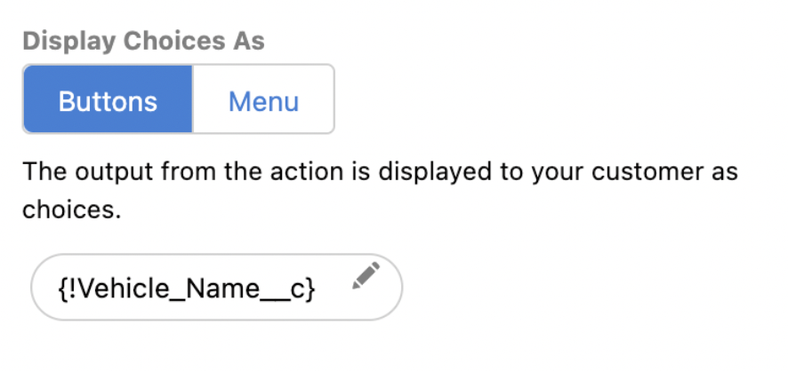

* 1. Click the **plus sign** below the Question dialog and select **Message**.
  2. In the Message text, enter **Let me find out what promotional offers are available for your vehicle. brb!**
  3. Click the **plus sign** below the Message dialog and select **Question**.
  4. For Ask a question, enter **Which promotion are you interested in?**
  5. In the Choice Type section, select **Dynamic: Choices populate based on an action or variable**.
  6. Select **Menu** for Display Choices As.
  7. Select **Flow** from the Action Type dropdown menu.
  8. For Action Name, select **EV Get Vehicle Promotions**.
  9. For the flow’s input **contactVehicle**, select **Selected Vehicle** for Variable Name.

**NOTE:** *The flow returns an array of objects for the promotions.*

* 1. In the Backup Rule section, select **Redirect to Dialog** for the Rule action and **Confused** for Dialog Name.
  2. In the Expected response format section, select **[System] Object (Object)** for the Entity Name.
  3. In the How to save the response section, for Save Answer to Variable, select **New Object Variable**, enter **Selected Promo** for Name, and click **Save**.
  4. Scroll up and notice the new section below Display Choices As.

**NOTE:** *This output from the action displays to your customer as choices.*

* 1. In the text field, enter **{!name}**.
  2. Click the **plus sign** below the Question dialog and select **Message**.
  3. In the Message text, enter **OK!! I’ll get the ball rolling on our end. Someone from the Service Dept will reach out to you with an appointment date. Let me get a case number for your service.**
  4. Click the **plus sign** below the Message dialog and select **Action**.
  5. Select **Flow** from the Action Type dropdown menu.
  6. For Action Name, select **EV Create Case**.
  7. For the flow’s input **promotion**, select **Selected Promo** for Variable Name.
  8. For the flow’s input **contactVehicle**, select **Selected Vehicle** for Variable Name.
  9. For the flow’s output **matchedCase**, select **New Object Variable** from the dropdown menu.
  10. Enter **Created Case** for Name and click **Save**.
  11. Click the **plus sign** below the Action dialog and select **Message**.
  12. In the Message text, enter **For future reference, your case number is {!Created_Case.CaseNumber}.**

**NOTE:** *You can copy this expression from the course snippets.txt file.*

* 1. Select the **Next Step** dialog at the bottom.
  2. Click the radio button for **Start another dialog** and select **End Chat** in the dialog box below.
  3. Click **Save**.
  4. Click **Activate**.

# Exercise 6-2: Create an Experience Cloud support site

**Scenario:**

EVs R Us wants to create an Experience Cloud site to give customers one place to find information about the company and products, access their data, and manage service request cases.

**Goal:**

Create an Experience Cloud site with an embedded chatbot for self-service customer support.

**Tasks:**

1. Create, configure, and publish Experience Cloud sites.
2. Add components to a site.

**Time:**

15 minutes

**Instructions:**

1. Create the site.
   1. Click  **Setup**, type **sites** in the Quick Find search field, and select **All Sites**.
   2. Click **New**.
   3. Select the **Customer Service** template.
   4. Click **Get Started**.
   5. Enter **EVs R Us Support** for Name.
   6. Click **Create**.
2. Configure the Content Security Policy (CSP).
   1. After the site is created, click **Builder**.
   2. Click the **Settings** gear on the left.
   3. Click the **Security & Privacy** tab.
   4. In the Content Security Policy (CSP) section, change the **Security Level** to **Relaxed CSP**.
   5. Click **Allow** in the modal after reading the notification.
3. Add the Embedded Chat component.
   1. Click the Components panel (the lightning bolt icon) and enter **chat** in the search field.
   2. Drag the **Embedded Service Chat** component and drop it on top of **Ask A Question**; you should see the following error message.

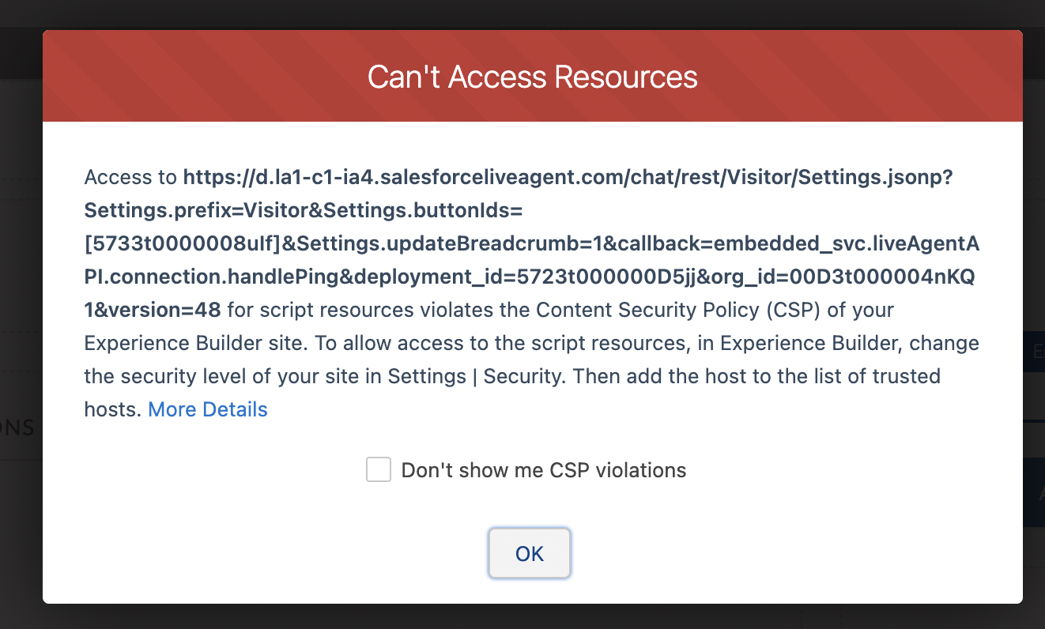

* 1. Copy the host in the modal, in this case https://d.la1-c1-ia4.salesforceliveagent.com, to your clipboard.
  2. Click **OK**.

1. Add a trusted site.
   1. Click the **Settings** gear on the left.
   2. Click **Add Trusted Site**.
   3. Enter **Live Agent** for Name and **paste the URL**.
   4. Click **Add Site**.
2. Publish the site.
   1. Click **Publish** in the upper right.
   2. **Copy the URL** for the new support site and click **Publish**.
   3. Check your inbox for an email entitled **Site Published Successfully.**
   4. Click the link in the email to open the site.
   5. After the site opens, ensure the chatbot loads correctly in the lower-right corner.

